**Suggestion:**

**Mead Composition Book (Size: 9-3/4" x 7-1/2", with secure sewn binding and stitched in sheets.)**

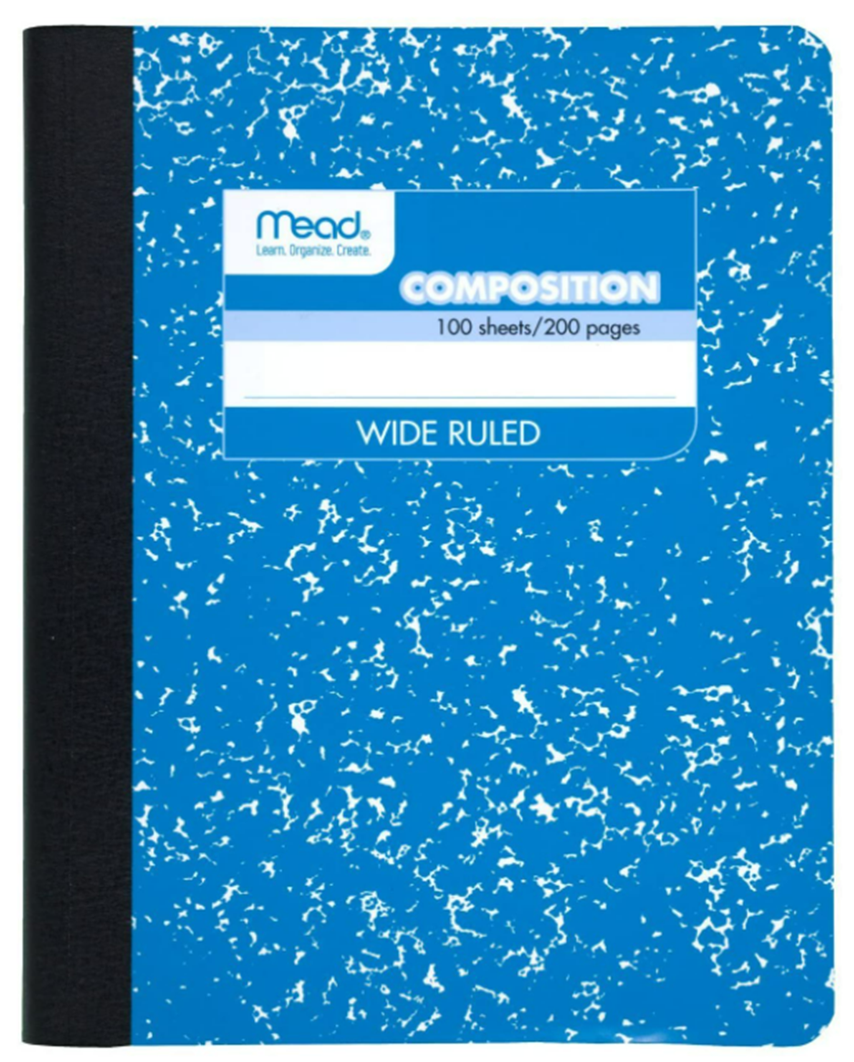

* Do not use the other type & size notebook!
* It is necessary to add counting numbers to both the front and back pages.

**Important: Your organized notes and calculations will help you at the end of the semester to use your notebook's notes during the lab exam!**

**Laboratory Notebook:**

1. Laboratory results must be placed in a laboratory book as described below:
   1. Pages in the notebook should be numbered & dated.
   2. **Blue or black ballpoint pen** is the only acceptable writing implement. Erasable ink is not acceptable.
   3. If you make a mistake in your notebook, draw a single line through the incorrect entry and then write your correction. (No scribbles or white out)
   4. First page (Your name, Course title/number)
   5. Second page (Table of Content)

**Table** of contents designating the title of each experiment and page upon which it starts.

* 1. Third page (Lab Safety Map)
  2. Fourth page (Cleaning methods)
  3. Fifth page (the first experiment...)

1. Experiments:
   1. Title of experiment & date initiated.
   2. Brief objective statement. (One ~ two sentences)
   3. Methods (main parts), referring to the laboratory procedure handout (note any changes in standard procedures if you get). (Do not copy/paste subjects from your lab manual or textbook)
   4. Write down observations (i.e.: the color, temperature, odor, or bubbles involved...) A simple drawing of the experimental apparatus is useful. Be sure to label all pieces of equipment. You do not need to draw any electronic devices. The purpose of the diagram is to show how several pieces of laboratory equipment are assembled into a working experimental apparatus *, **.
   5. Pre-Calculation: It must be contained a short **title** about your calculation. Keep all lines of calculation (including units) in order.



Date: 1/29/08

*NOTE:*

Page: 5

*I did touch the crucible with my hands; I think there is a weighing error for (8.1769 g). After reheating/cooling, its new weight is 8.1741 g.*

***Watch***

***glass***

Up turned cap.

*Weighing*

Marking *Bottle*

*Time: 8:25 temp. ~114**C*

*An example

** An example: *Solid AgCl has a gray color.*

1. Data
   1. All data, comments, calculations, timetable plans, etc. pertaining to the work done during an experiment should be entered directly into the notebook and not onto any other paper or book. THINK IN YOUR NOTEBOOK!
   2. In science, all measured quantities have a number and a unit. Without the units, the measurement has no meaning.
   3. If you have a table of measured quantities, add units to the top of each column.

|  |  |  |
| --- | --- | --- |
| Title of table: ? | | |
| Run | mass **(g)** | Volume **(ml)** |
| 1 | 10.3467 | 5.0 |
| 2 | 10.3872 | 5.5 |
| 3 | .. | .. |

* 1. If you have a table of mixed quantities, add units to the front of each row.

|  |  |  |  |  |  |  |
| --- | --- | --- | --- | --- | --- | --- |
| Title of Table: ? | | | | | | |
| Run | | Type of quantities | | Value | | Units |
| 1 | | Mass of container | | 0.23451 | | g |
| 2 | | Mass of Na2CO3 | | 0.0562 | | g |
| 3 | | Volume of Acid | | 100 | | mL |
| 4 | | Temperature | | 23.40 | | °C |
| 5 | … | | … | | … | |

* 1. Results including all raw data (check significant figures & units) and calculations used to get final, reportable data along with pertinent comments. (I.e. enter data as you go; don't recopy neatly).
  2. Grading may change during each semester based on interest in the lab.

|  |  |
| --- | --- |
| **Any assigned grade may be changed** | |
| **Notebooks will be collected at random times** | |
| **Subject** | **Grade** |
| Bound Notebook / using Ink |  |
| Page number & Date |  |
| Table of Contents |  |
| Drawing lab map |  |
| Attached the correct Calibration Graph |  |
| Experiment Title & Objection |  |
| Units |  |
| Pre-calculation with short title |  |
| Observation & Comment |  |
| Clarify all data |  |
| Organized and readable |  |

General Hints:

|  |
| --- |
| First Page |
| Spring 202?  CH31 – Lab Notebook  Lab Section?  Full Name? |

|  |
| --- |
| Second Page |
| Table Contents |

|  |
| --- |
| 3rd Page |
| Lab safety map |

|  |
| --- |
| 4th Page |
| Initial notes about CH31 lab. Anything is new for you!  i.e.: Desiccator, Analytical Balance, glassware, … |

|  |
| --- |
| 5th Page |
| First Experiment … |