Working with the Taskstream Directed Response Folio (DRF)

- How do I access my Directed Response Folio?

Through the My Programs area you can access your Directed Response Folio. You should login to Taskstream and click on “My Programs” listed on the left hand navigation bar. On the Right Hand Window you should see the Professional Technology Standards. To access the DRF click on “Work on DRF.”

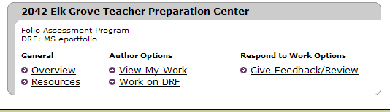

- How do I upload my assignments to my DRF?

You will use the edit content area to add all documents related to your signature assignments (text, images, files, and web links) to your DRF.

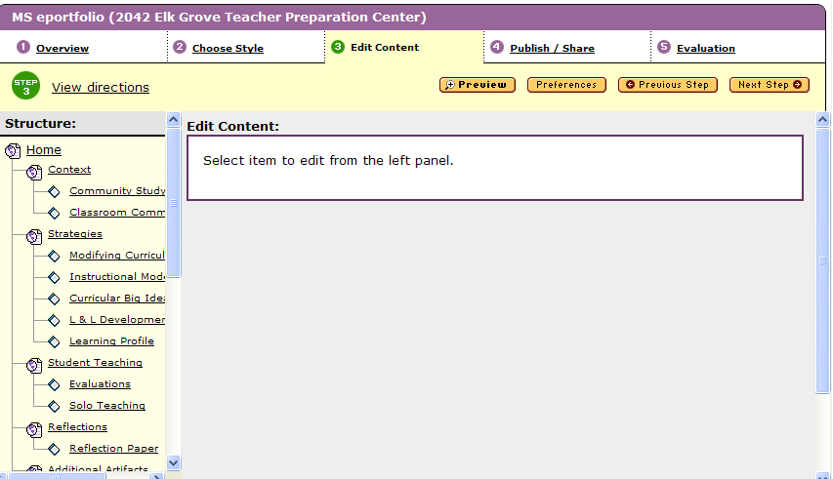

The left hand column shows all the sections of the DRF. Click on each of the signature assignments to access the content within. This content will be displayed in the right frame also known as the content area. To add your content to your DRF, select a standard in the structure tree (on the left hand side) and click the Add/Edit Work button in the right-hand content area frame to access the Content Editor.

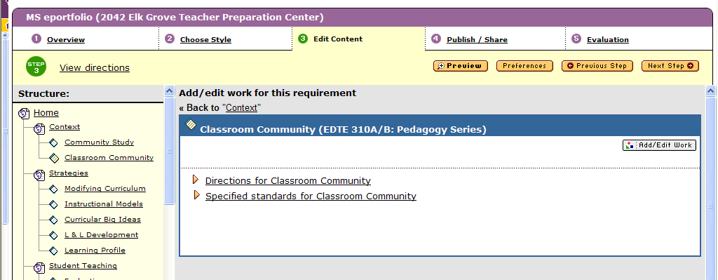

When you click on Add/Edit Work the Content Editor window opens which allows you to view directions for your assignment, Teaching Performance Expectations aligned with your assignment, and the rubric used to evaluate this signature assignment.
Click here to add text
Click here to attach files

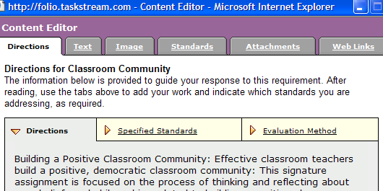

Within the content editor you have the option of adding text, images, standards, attachments, and web links by clicking on the corresponding tabs. The tab you will use most often will be the “Attachments tab” since this is where you can attach documents (word processing, PowerPoint presentations, etc.) that you have created for your signature assignment. You will not need to use the standards tab. The following steps show you how to add text, images, attachments, and web links for each signature assignment.

Adding Text
To add Text click the Text tab of the Content Editor and type your text into the text entry box. In the text area you should provide a brief description of the artifact. Click the Spell Check perform a spell check. Once you have finished click on Save and Close Window.

Adding an Image
In the Image section of the Content Editor, you can either upload an image from your own computer or disk or you can choose from a selection of Taskstream clip art. To add your own image, click the Browse button. A dialog box will open, allowing you to select and open the image file from your computer. The path of the file will appear in the Browse field. To select a stock image, click the title of the image you want to use and a preview of the image will appear in the area to the right of the image list. After the image has been selected or designated for upload, you can select the alignment of the image. Click the Add Image button to complete the process.

Adding Attachments:
New Files
When you click the Attachments tab in the Content Editor, you will notice that the menu defaults to the New File attachment form.
1) Name the new file.
2) Use the Browse button to locate the file on your computer.
3) You can add a description to your file.
Click the Add File button to attach and upload your file. As files are attached, they will be listed at the bottom of the form where they can be edited or deleted.

Previously Uploaded Files
If you have file attachments that have already been attached to any of your work in TaskStream, you can easily attach them by clicking the Previously Uploaded Files link.
1) Select the category area in which the file is currently attached.
2) Select the file that you want to attach in this area.
3) Rename and/or add a description for the file.
Click the Add File button when you are finished. Added files will be listed at the bottom of the form where they can be edited or deleted.

My TaskStream Work
You can attach your TaskStream work by clicking on the My TaskStream Work link in the Attachments tab.
1) Select the work category that you would like to attach from the first pull down menu.
2) Use the second pull down menu to select the title of the work.
3) You can add a description of the work in the text entry field provided.
Click the Add File button when you are finished.

Adding Web Links
The Web Links tab of the Content Editor window contains a form for linking other web pages to your DRF. You can use this form to link to external web sites and/or to existing pages within your DRF. To add an external web link, enter the name of the link in the first entry field and the associated URL in the second field.
If you have multiple pages within your portfolio, you can link any of these pages to the current page by using the Link to Existing Page pull down menu. A description field allows you to add annotations for the linked web pages.
Click the Add Link button when you are finished.
Added links will be listed below the form where they can be edited or deleted.

- How do I submit my assignment to my instructor for evaluation?

To send your work for evaluation, click the Step 5: Evaluation tab at the top of the Directed Response Folio.

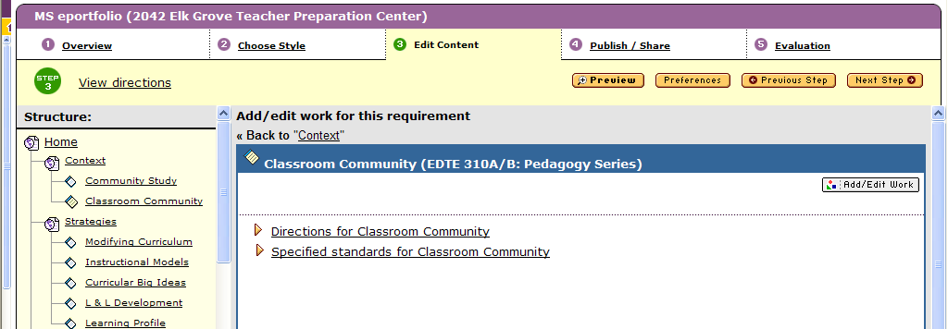

The evaluation page contains a chart displaying five columns. The ‘Description’ column displays the structure of your DRF. The ‘Status’ column displays the progress of work submissions. The ‘Submit work’ column contains a Submit button if there’s an item waiting to be submitted for evaluation, a Cancel link if the item has been submitted but not evaluated, or nothing if the evaluation has been completed. The ‘Evaluation outcome’ column displays the evaluation. The Points awarded column displays the total points awarded for that item. To submit your work for evaluation, click the appropriate Submit and follow the resulting directions. Select the instructor from the list of evaluators. Once your work has been submitted for evaluation, it will automatically lock and a lock icon will appear next to it. This will prevent you from adding additional work, or editing existing work until your instructor has reviewed your work. (If you will be submitting a document for more than one assignment and would like to add more information, you can make a copy in your lesson builder and put a 1 after the title of the plan.)

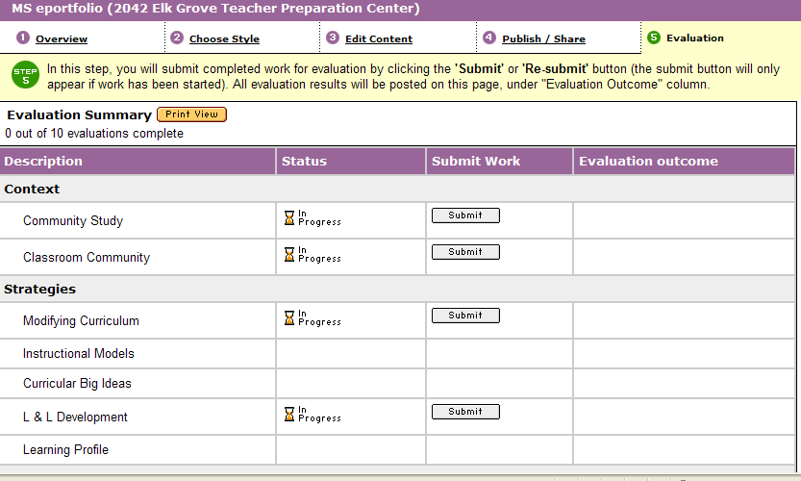

- How will I know the progress of each assignment and the evaluation results?

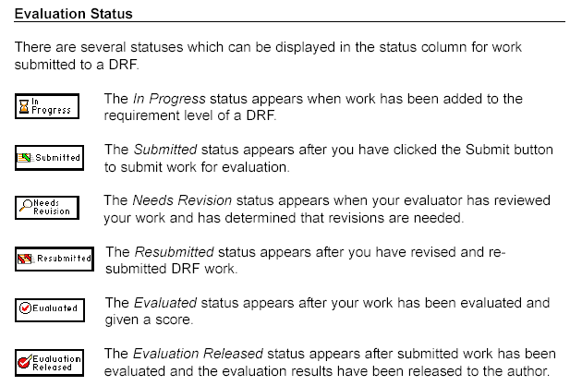

Once your work has been evaluated and the evaluation has been sent to you, you will see your assessment results in the ‘Evaluation outcome’ and ‘Points awarded’ columns. These areas will display the assessment evaluation and score given to your submitted work.

- How can I convert my DRF into a presentation portfolio for interviews?

Once you have completed all DRF requirements and received all evaluation results, you may want to create a presentation version of the DRF that does not include the directions and to which you can add additional artifacts.

To convert your DRF to a portfolio, go to the Web Folio Builder. Click on View/Edit my Directed Response Folios. Click the Save As/Copy link next to the DRF you would like to copy.

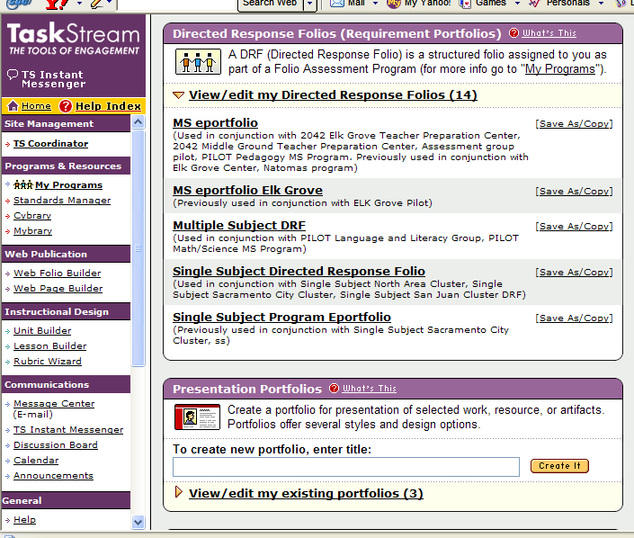

Enter a new name for your web folio. Then click the Submit button.

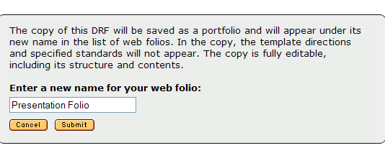

The copy will appear in the Presentation Portfolios area with the new name. You will now be able to edit and further personalize the portfolio. The portfolio will not contain the instructions, evaluation scores, or reviewer comments. You will, however, still be able to continue editing your DRF and submitting the work done in your DRF.

