EXPERIMENT 1: LINKAGE MAPPING IN DROSOPHILA MELANOGASTER

DAY ONE: INTRODUCTION TO DROSOPHILA

OBJECTIVES:

Today's laboratory will introduce you the common fruit fly, Drosophila melanogaster, as an experimental organism and prepare you for setting up a mating experiment during the next lab period. After today’s experiment you should be able to:

- Properly anesthetize and handle Drosophila.
- Properly adjust a stereo dissecting scope and light source for optimal viewing of Drosophila.
- Distinguish males and females, and have a record for your own reference.
- Distinguish wild-type from mutant characteristics and have a record for your own reference.
- Understand the meaning of “single, double, triple, and multiple mutants.”
- Be familiar with symbols for mutant and wild-type alleles used by Drosophila geneticists.

INTRODUCTION:

Drosophila melanogaster is used extensively in genetic breeding experiments. It is an ideal testing organism for geneticists because it has a short life cycle, exhibits great variability in inherited characteristics, and may be conveniently raised in the laboratory to produce large numbers of offspring. Drosophila can be used in genetic crosses to demonstrate Mendelian inheritance as well as the unusual inheritance of genes located on the X chromosome (“sex linkage”). The organism is also useful for demonstrating the principles of genetic mapping, which you will be exploring in this first experiment. To do this, you will be performing a cross with real flies to demonstrate the principles behind genetic mapping. Your success in these experiments will depend greatly on your ability to properly handle the flies and to accurately observe their characteristics.

Techniques for Handling Drosophila

Many characteristics of Drosophila must be examined under a stereo dissecting microscope. Flies are immobilized by anesthesia when they are examined or being transferred for mating. You must master the techniques of anesthetizing, handling, and examining the flies before attempting to make a cross.

Traditionally, flies were anesthetized with ether. Now, because of potential health hazards, student laboratories use carbon dioxide or FlyNap to render flies unconscious. Both of these have the advantage over ether of being relatively harmless to humans and free from overdosing dangers to the flies. Carbon dioxide gas must be continually applied to flies (through a diffusion plate that sits beneath the microscope). While this is the most common anesthesia in fly laboratories it requires a fair amount of hardware and plumbing that is not very portable. In this lab we will be using FlyNap. While the package directions tell you how quickly the FlyNap will work, you must watch the bottle to see when all of the flies become still. You will also notice a distinctive odor of the FlyNap; this causes adverse physical symptoms in some people. Hence, used wands should be placed in a capped vial and the use of FlyNap should be minimized. If you find yourself reacting unfavorably to the odor, just step outside for some fresh air.

Unconscious flies should be placed on a counting plate or index card for sorting and examination. When a dissecting scope is used, the light source should be adjusted so that the rays of light fall directly on the fly. Adjust the eyepieces of the microscope to the correct interpupillary distance of your eyes; this is important to obtain stereo vision. Use low magnification for scanning and sorting, and high magnification for checking the detailed structural features. To manipulate the flies while viewing under the microscope, a camel hair brush should be used. Through practice you will be able to turn the flies over and move them about freely. Learn to manipulate the fly gently so that it will not be injured or killed. You can push the fly with the brush or lift it with a slightly moistened brush.

When unconscious flies are introduced into a container, do not drop them directly on the food or any moist surface. The flies will stick to the moist surface and usually cannot escape. Place the flies on the dry inside side of the bottle and keep the bottle lying on its side until the flies awaken. If flies get stuck on the food, tap the side of the bottle against the bench to dislodge them. In general, this is a useful practice just prior to returning flies to the incubator.

Identification of Sex

Male and female adult flies (Fig. 1-1) can be distinguished from each other by the following criteria:

- Sex comb: Male flies have sex combs; female flies do not have them. The sex comb (Fig. 1-2) is located on the proximal tarsal joint of each of the forelegs of the male. It consists of a row of about ten stout bristles. Under the dissecting scope, however, it appears as a tiny black spot.
- Abdominal structure: From a dorsal viewpoint, the male has heavy pigmentation at the posterior part of the abdomen with two pigmented bands anterior, while the female has five pigmented bands along the entire abdomen. The posterior end of the abdomen is rounded in the male, but somewhat pointed in the female, for ovipositing. For those adults that have emerged from their pupal case within the last hour, pigmentation is very light and more difficult to use in distinguishing sexes (flies will look very pale and their wings may be wrinkled).
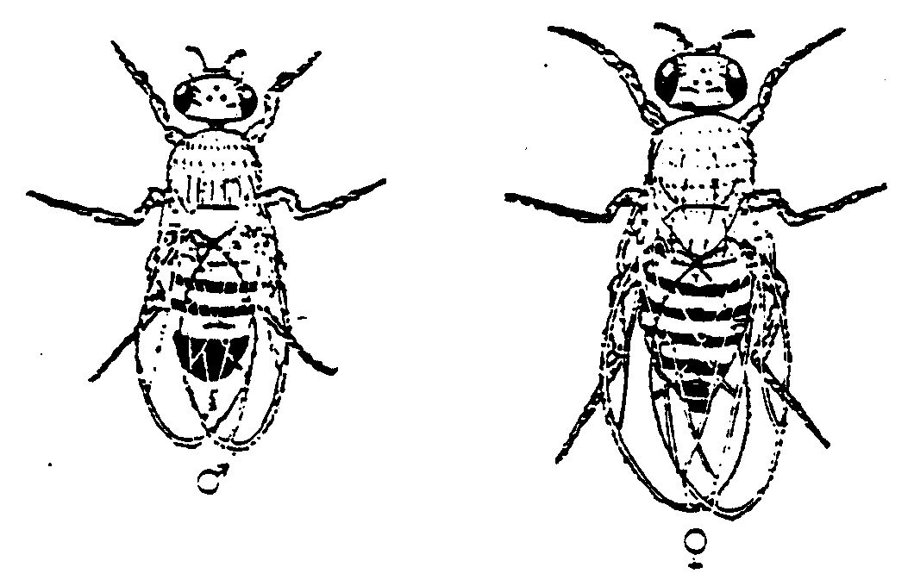
- Genital region: The genital organs are visible from the ventral side. The penis of the male is surrounded by dark and heavily bristled genital arches, while the vaginal opening of the female is covered by a light ovipositor plate.

The fastest, most commonly used method of identifying flies by sex is a combination of abdominal structure and genital region. Both are easily visible with a scope, and with a little practice can allow identification with minimal manipulation. The sex-comb criterion is also frequently used for sex identification because of its reliability and the ease of observing the sex combs. Since the sex combs are visible through the pupal case in the mature pupa, it is possible to identify the sex of a fly before its emergence from the pupal case. As you become more experienced you may be able to distinguish the sex of the flies with your naked eyes by viewing the abdominal bands.
Figure 1-1. Male (left) and female (right) adults of Drosophila melanogaster.

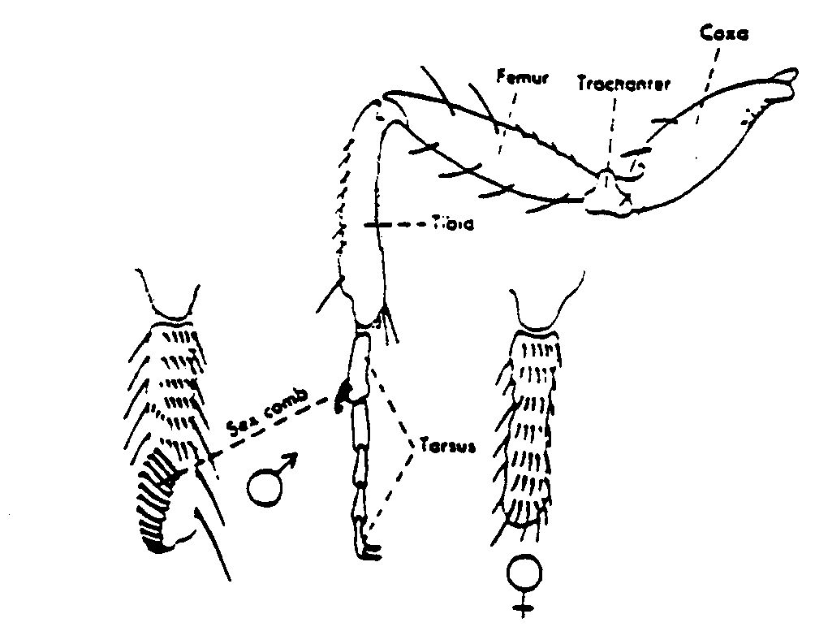
Figure 1-2. Foreleg of male Drosophila, showing sex comb. The proximal tarsal segment is enlarged to show the presence of the sex comb in the male and its absence in the female. Sex combs are used to displace the females wings during copulation (they do it doggie style).

Identification of Mutants

Thousands of mutant strains of Drosophila have been collected in the laboratory for genetic studies. A mutant fly differs from a normal (or wild-type) fly in one or more heritable characteristics. The characteristic exhibited by the mutant is due to a change in the normal DNA sequence or its location. Such a change is called a mutation. Mutations may affect the morphology, physiology, or behavior of the fly. A list of common mutations, including line drawings and photographs of the more common ones, may be found in the Drosophila manual provided in the lab. A name and symbol are designated for each mutation in Drosophila, and this nomenclature differs somewhat from the standard nomenclature first developed by Mendel. Recessive mutations are expressed in lower case letters, while the name and symbol of dominant mutations begin with a capital letter. A symbol with a + superscript designates the wild-type allele of a given mutant gene; sometimes just a + is used to designate the wild-type allele. Note that if the mutant allele is recessive, then the wild-type allele must be dominant, and vice versa. Note also that most mutant alleles are recessive, but dominant mutations do exist.

The following examples illustrate the difference between standard Mendelian nomenclature and the nomenclature used for Drosophila. The advantage of the Drosophila method is that the wild-type allele can be immediately identified, whereas the Mendelian nomenclature does not provide this information.

Mendelian nomenclature is used for identifying alleles in humans. In humans, the disease cystic fibrosis is under the control of a single gene: “Cf” = disease-free; “cf” = cystic fibrosis. Note that it is impossible to tell from the nomenclature alone which allele is wild-type and which represents a mutation. In Drosophila, the trait of wing curliness is also under the control of a single gene: “+” = straight; Cy = curly. In the Drosophila nomenclature, we can immediately see that the wild-type trait is non-curly wings, and that the Curly allele is dominant to the wild-type (non-curly) allele.

A fly carrying one identifiable mutation is called a single mutant. Those exhibiting two, three, or multiple mutant traits are double, triple, or multiple mutants, respectively. Morphological mutations usually involve color, size, or shape of the eyes, bristles, wings, or body. While some mutations are easily recognized with the naked eye, many others can only be identified by a careful comparison between wild-type and mutant flies under a dissecting microscope. You should practice the skills of mutant identification required for accurate and rapid phenotypic classification of large numbers of flies. While morphological mutations are convenient for use in student labs, many other kinds of mutants (e.g. behavioral, developmental, biochemical) have been studied to gain knowledge of these processes in lower animals.
THINGS TO DO:

- Through lecture and discussion, learn the principles and methods of using Drosophila for genetic studies and the objectives of our lab exercises in Experiment 1.

- Find your equipment for working with the flies: Fly manual, index cards, sorting tray, camel hair brush, FlyNap, dissecting microscope and light (in back cabinet), fly morgue.

- Practice the techniques of anesthetizing and handling flies as demonstrated by your instructor.

- Isolate several flies from a wild-type stock bottle and identify the sex of each. Also make note of the wild-type color, size, and shape of the eyes, bristles, wings, and body.

- Examine flies from demonstration stock bottles for the identification of various mutations exhibited by single, double, or multiple mutants. To avoid contamination of the stock, do not return the unwanted flies to the stock bottle; reservoir bottles will be available. To conserve flies, groups may be assigned to set up specific stocks for observation. As you view these stocks, record in words and drawings how you can distinguish each mutant characteristic from the wild-type. Again, focus particularly on colors, shapes, and sizes of eyes, wings, bristles, and body. From your notes, you should be able to identify these mutants when you see them again. You will have about 30 minutes to continue your observations in the next lab period, so take your time and take careful and thorough notes and sketches of your observations.

DAY TWO: SET UP CROSS FOR GENETIC MAPPING

OBJECTIVES:

Today you will finish examining mutant phenotypes and then make a cross that will allow you to determine the genetic map distance between three genes located on the X chromosome in Drosophila. After today’s lab you should:

- Know how to perform a cross in Drosophila.
- Be able to draw out the mating that was performed by the laboratory technician to create the males and females you crossed today.
- Be able to draw out the cross you performed and predict the phenotypes of the offspring that should result.
- Know how to accurately identify the three mutant characteristics being followed in the cross.
- Know the phenotypes and numbers of male and female flies that you crossed.

INTRODUCTION:

As Mendel demonstrated with pea plants, much can be learned about the basis for an organism’s characteristics if the right kinds of controlled crosses are made. Pure-breeding or homozygous stocks are first made by inbreeding organisms with the desired form of a trait (or traits) for many generations, until only that form is observed in the offspring. The resulting stocks are then presumed to have just one form of genetic information for that trait. For convenience, we obtain such stocks from supply houses and then maintain them by inbreeding in our culture collection.

To get information about how the trait is determined, individuals homozygous for different forms of the trait must be crossed. Their offspring are known as F1s and should be heterozygous (with a different form of genetic information for the trait from each parent). Seeing which form of the trait is expressed in the F1s shows us which form of the information (or allele) is dominant. Moreover, crossing the F1 with another F1 or with a tester (homozygous recessive individual) will show us how many genes determine the trait, since we can predict what fraction of offspring should exhibit different forms of the trait if they are determined by 1, 2 or more genes. When we are working with traits that have already been shown to be simple traits (controlled by one gene in a diploid organism), we can cross-multiply heterozygous F1s with other F1s or testers to see the numbers of offspring with different gene combinations passed on by the F1. This information, showing up in the combinations of traits exhibited by the offspring, tells us whether genes for the different traits are on different (independently assorting) chromosomes or whether they are linked on the same chromosome. If they are independently assorting (or unlinked), the genes for the different traits have an equal chance of being passed on in any possible combination.

For example, a cross between two pure-breeding parents, where one is (+/+, +/+) and the other is (ey/ey, eb/eb) would yield an F1 generation, all of whom are doubly heterozygous (+/ey, +/eb). (ey is a recessive mutation that renders the flies eyeless, and eb is a recessive mutation that causes an ebony, or black, body color.) If these F1s are then crossed to a fly with the genotype (ey/ey, eb/eb), and the two genes assort independently, then the F2s should fall into the following four phenotypic categories in equal numbers: eyeless, ebony; eyeless, wild; wild, ebony; wild, wild. This is because the F1 parent will produce equal gametes of each possible type, and the doubly recessive mating partner (also called the tester) cannot contribute any alleles that would “cover up” the genotype contributed by the F1.

On the other hand, if the genes are linked, the same F2 phenotypes will be produced, but they will not be produced in equal numbers. Two of the classes will have fewer offspring than predicted and two will be enriched. The two smaller classes are the recombinant offspring because they represent offspring that received gametes from the F1 parent that recombined (underwent crossing over) during meiosis. For example, if the F1 parent carries ey linked to eb on one chromosome and + linked to + on the other, any gamete that has the genoytype ey,+ or +,eb must have arisen during a cross over event and would be deemed a recombinant gamete.

The numbers of offspring that received these recombinant gametes tells us how close the genes are to one another on the chromosome. This is because genes that are very close together are less likely to undergo recombination than genes that are farther apart. Therefore, the data from crosses between an F1 and a tester (also called a test cross) allow us to generate hypothetical genetic maps. For linked genes, the genetic map distance between genes is defined as:

(# recombinant offspring) x 100 map units
# total offspring

The F1s we will be crossing in lab were made by the lab staff. About two weeks ago, they bred pure-breeding triple mutant females to pure-breeding wild males. You will be crossing F1 males with F1 females (i.e. inbreeding brothers and sisters!). However, as you examine these F1s before crossing them, you should notice something unusual about them, which makes this cross equivalent to a test cross. Your instructor will discuss this with you in further detail, but you might want to think on your own about how this might happen.

Culturing and Crossing Drosophila

In the laboratory, fruit flies are raised in culture bottles containing cooked food. A variety of recipes are available for preparing culture media. The popular molasses-cornmeal medium is used in our laboratory for most experiments. The medium provides a balanced diet for the flies and contains mold inhibitors to maintain its freshness. A few granules of yeast have been added to the medium in each bottle to promote the active growth of the flies. Sometimes contamination of the medium by mold and/or bacteria occurs. Contamination should be noted in your laboratory records, in case it affects the outcome of your cross. Additionally, some bacterial contamination leads to softening of the medium and the entrapment of flies when you invert the bottle. Any time you see soft medium, report it to your lab instructor and harden the medium by the addition of instant medium.

Drosophila cultures should be incubated at 25º C. If an incubator at that temperature is not available, the culture will do well at room temperature (20-24º C). Extremes of temperature should be avoided. Flies exposed to 31º C or higher temperatures for several hours may become sterile; thus Drosophila cultures should be kept away from direct sunlight to avoid a rise of temperature inside the bottle.

In making a cross, 3 to 5 pairs of selected male and female flies are placed in a fresh medium bottle. Remember that unconscious flies must be placed on a dry surface; not on the medium. In a pinch, a single male can be used to inseminate several females. The sex and phenotype of each fly used in the cross should be carefully checked and recorded, and the bottle should be properly labeled. Virgin females are required in many cases to make a cross. After emerging from their pupal case (eclosion) adults remain virgin for at least 10 hours, during which time the sexes can be separated and held until crosses are made For today’s lab, we have chosen to do a cross for which you do not have to isolate virgins. You should be able to figure out why.

THINGS TO DO:

- Continue to study the mutants provided. Make sure you can identify a mutation without referring to the label on the stock bottle. Keep a wild type fly handy as a reference, so that you can clearly see the difference between the normal and mutant characteristic. Half an hour before the end of lab, return all stocks to the front bench and make sure there are no loose flies at your bench.

- Perform your cross. Each pair will receive one bottle of flies, marked with a cross number. The flies inside the bottle are the F1 offspring of crosses made 2 weeks ago by the lab staff. The different numbers on the bottles indicate different crosses. Each cross was made between a certain pure-breeding triple mutant stock and a pure-breeding wild-type stock. The mutations of the mutant parental flies are among those exhibited by the demonstration stocks. Examine the F1 generation flies and classify them according to sex and phenotype. Select a random sample of at least 10 flies from the bottle and count every fly in the sample. Record and tabulate the group data. IF THERE ARE 2 OR MORE PHENOTYPIC CLASSES IN ONE SEX, CONSULT YOUR INSTRUCTOR BEFORE MAKING THE CROSS.

- Obtain one bottle of fresh medium. Make sure that no stray flies have entered the bottles and that the sides of the bottle are free of moisture, which could trap unconscious flies. If there is moisture in the bottles, dry them out with a paper towel.

- After the flies have been counted, place a small pinch (10-20 grains) of yeast on the fresh medium. (Don’t do this too far ahead of time as it becomes sticky after hydrating). Place 3-4 males and 4-5 females into your bottle. To do this, place a plastic funnel over the fresh bottle and hold the bottle at a 30 degree angle. Brush or dump the selected flies into the bottle. Take care to put the bottle on its side so that the flies will be on dry glass, rather than the moist food. Tap the side of the bottle against the bench if flies appear stuck on the medium. These flies will start the F2 generation. Label the bottle with the cross number, your initials, your lab section, and the date. Place your cross at 25ºC in the walk-in incubator at the back of the room. Place your labeled bottles on the shelf designated for your section. Keep the bottle on its side if the flies have not yet regained consciousness.

LOOKING AHEAD:

Think about how your cross is similar to a Mendelian cross and how it is different. Why is this cross equivalent to a test cross? Why is this fact important for the purposes of this lab?

DAY THREE: DROSOPHILA LIFE CYCLE

OBJECTIVES:

Today you will be checking the progress of your cross and observing stages of the Drosophila life cycle. By the end of today’s lab you should

- Be familiar with the stages and timing of the Drosophila life cycle.
- Be able to identify the stages in a culture.
- Have a good idea of whether your cross is proceeding normally.
- Understand why it is important to know the life cycles of organisms used in genetic studies.

INTRODUCTION:

When organisms are used in genetic studies, it is important to know their life cycles. One reason is that you want to know how long you must wait for offspring in order to plan wise use of your time. An elephant cross, for example, would require that you fill your time for 2 years before having offspring to analyze! A second reason for being familiar with the life cycle is so that you can monitor the cross and know that it is progressing normally. If you know the timing of the developmental stages before the offspring emerge, you can look for the expected stages and note any irregularities. Still a third reason to know about the life cycle is to facilitate the handling of materials. For instance, knowing that recently emerged adults show sexual characteristics, but are unable to mate, allows the early isolation of virgin females for controlled crosses.

The Life Cycle of Drosophila

The life cycle of Drosophila is shown in Figure 1-3. The fertilized egg is laid by the adult female shortly following fertilization. The eggs hatch about one day after they are laid and produce small white larvae. The larvae feed upon food and grow rapidly. During its development, the larva undergoes two molts and three instars. At 25ºC, a first instar will become a mature third instar in about four days. The third instar larvae crawl up out of the medium, adhere to a dry surface, and develop into the pupae. Pupation takes about three days, during which the larva within the pupal case undergoes metamorphosis and transforms into the imago or adult form. The adult emerges by forcing its way through the anterior end of the pupal case. The newly emerged fly is slender, light-colored, and has folded wings. After about two hours, the wings will expand and the body will become darker and more compact. The male adults are capable of fertilizing the females ten hours after their emergence. When the flies are cultured at 25ºC under optimal conditions, the entire life cycle from egg to adult is completed in about ten days. At room temperature, the life cycle may be completed in two weeks.

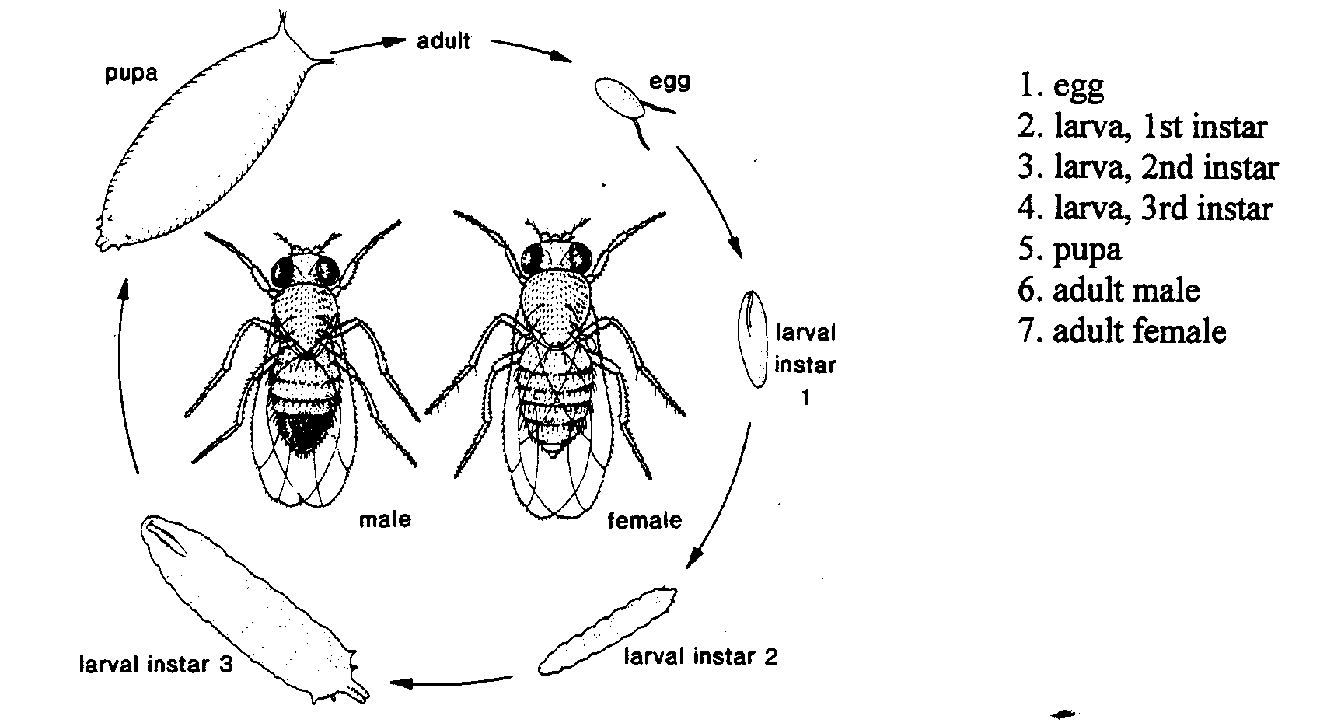
Figure 1-3. The Life Cycle of Drosophila

THINGS TO DO:

- Check your cross to make sure that the F1 flies are in good condition. First, look for eggs on the surface of the medium. You can see these in two ways: 1) Look through the glass. You should see very small white dots (embryos). They will be clustered around the pinch of yeast. Most of the yeast itself should no longer look granular. It will now be a thick liquid. This is due to enzymes released by the larvae as they graze. 2) Bring the bottle to eye level and tilt it such that the bottom is slightly above the opening. Pinch back the sponge stopper from one side. You will now have a clear view of the bottom. You should see many embryos. If you don’t see them or are not sure, ask your instructor to take a look. You can add more adults if necessary. If you have 100+ eggs (ask your instructor if you are having trouble estimating the number) then discard your adults to prevent overlaying. (The food will become overly liquefied and spill out onto your desk when you attempt to remove F1 adults next week.)

To discard adults (read before doing): 1) Place your funnel over the fly morgue, (2) while tapping the bottom of your bottle against your bench (to keep flies away from the opening) remove the plug and immediately turn the bottle upside down and against the funnel. Holding the funnel against your bottle, raise both and tap them against the morgue briskly until the adults are all in the morgue (where they die immediately).

After your adults are discarded, examine the surface of the medium. You will have a clear view of the “eggs” (embryos). Also look for larvae inside the medium. You may recognize them at first by their movement, as they actively feed with small black mouth parts. You may also see thin trails made by the larvae as they graze the surface of the medium. Then examine the sides of the bottle near the medium. You may see 1st and 2nd instar larvae. If so, using the dissecting microscope, viewing through the side of the bottle. If the flies did not survive or if there is evidence of contamination, start the cross once more, using F1 flies available to you. Once you have observed your cross, put it back into the walk-in incubator until next time.

2. Study the life cycle of Drosophila. Find eggs, larvae, pupae, and adult flies from the bottles on the front bench. Observe them with the dissecting microscope through the glass bottle. In order to do so, you will have to lay the bottle on its side and adjust the height of the optical system. With one hand supporting the optical system, loosen the large screw on the back of the dissecting scope stand. Then raise the optical system to a height where you can see the top side of the bottle by adjusting the focusing knob; retighten the large screw.

3. If there is time remaining, figure out the different phenotypes of F2 offspring you expect. You can assume that each trait is under the control of one gene and that one allele is dominant to the other at each locus. Then figure out the expected fractions of each type if all three genes are located on different chromosomes. How about if the genes are all located on the same chromosome and therefore exhibit linkage effects?

DAY FOUR: PROBABILITY AND PEDIGREES

OBJECTIVES:

Today you will be seeing the rules of probability in action. By the end of today’s lab you should be able to

- Construct and analyze a pedigree.
- Understand the basic rules of probability.
- Understand how the rules of probability can be applied to predict the genotypes and phenotypes of offspring from a genetic cross.

INTRODUCTION:

When you made a prediction about the outcome of your F1 x F1 cross, based on certain models of how the genes for different traits were carried on the chromosomes, you might have listed all possible gene combinations, or organized them in a Punnett Square, or just used rules of probability. We can use rules of probability to predict an outcome if we have some idea of how the genes are being transmitted. What is incredible is that Mendel observed results agreeing with those predicted by probability and specific transmission patterns and that he deduced these patterns without knowing about chromosomes or DNA! In today’s lab we will be using tossed coins as examples of chance events, to see how the rules of probability used by geneticists can be observed in a simple system with which we are all familiar.

Chance events are random ones, occurring without any particular pattern. A probability is just the fraction of the time in the long run that a particular chance event will occur. One of the basic rules of probability is that the probability of any chance event is the number of events in question divided by the total number of events possible. For example, given a fair coin, with one side head and one side tails, the probability of a toss coming up heads is 1 [the number of heads]/2 [the total number of sides possible]. This rule of probability is sometimes called the Sampling Rule.

Often times we are interested in the probability that two independent chance events occur simultaneously, where independent events are those that do not influence each other’s outcome. Here the rule is that the probability of the independent events occurring simultaneously (prob of A and B) equals the product of their individual probabilities (prob of A x prob of B). For example, when tossing a fair coin twice in a row, the probability of getting a tail the first time and a tail the second time is (1/2)(1/2) = ¼. This rule is called the Product Rule.

At other times, we may want to know the probability of one event or another mutually exclusive event occurring, where mutually exclusive means the two events cannot both occur. In this case, the probability of one or the other occurring (prob of A or B) equals the sum of their individual probabilities (prob of A + prob of B). For example, when tossing a fair coin one time, the probability of getting either a head or a tail is (1/2) + (1/2) = 1 (or 100%). This rule is called the Sum Rule because the probabilities are added together rather than multiplied.

You can likely think of your own examples to illustrate these rules. We hope this lab exercise reinforces your understanding and allows you to become comfortable applying the rules of probability to genetics problems. One practice that might help is to remember your own examples and draw parallels. For example, you may know that the probability of rolling a one on one die and a one on the other (snake eyes!) is 1/36; it might be helpful for you to think about all of the steps you automatically took in finding this:
- There are six sides on a die and only one of them has one dot, so the probability of randomly rolling a one is 1/6.
- The way that one die comes up is independent of the way the other die comes up; so the probability of both coming up with ones is 1/6 x 1/6.

As another example, you know that the probability of drawing a face card from a deck of cards is 12/52. Again it may be helpful to remind yourself that this is because a face card is a king or a queen or a jack of each of 4 suits and drawing one of these is mutually exclusive of drawing another. Hence, there would be 12 different face cards you could draw from a total of 52 cards.

When you are confident working with two of the rules of probability, you can move on to using all three. It is always helpful to try to identify in words the independent and/or mutually exclusive events you are working with. For example, to find the probability that rolling two dice will produce a sum of 7, you first need to determine how many mutually exclusive ways this can happen:

1 on the first and 6 on the second = (1/6)(1/6) = 1/36 5 on the first and 2 on the second = (1/6)(1/6) = 1/36
3 on the first and 4 on the second = (1/6)(1/6) = 1/36 4 on the first and 3 on the second = (1/6)(1/6) = 1/36
6 on the first and 1 on the second = (1/6)(1/6) = 1/36 2 on the first and 5 on the second = (1/6)(1/6) = 1/36

You can then add these probabilities together to get the final answer of 6/36 or 1/6.

You can apply a similar method to finding the probabilities of getting offspring with certain genotypes and phenotypes, remembering that an offspring is a random sampling of one gene for each trait from each parent. The parents’ contributions to the offspring are independent events; and a contribution of one allele for a trait is mutually exclusive of a contribution of another allele for the same trait.

One very practical genetic application of the rules of probability is in pedigree analysis. Pedigrees are charts of phenotypes in a family, which may make patterns of inheritance and predictions about future offspring apparent. Before a pedigree is done there must be some inkling that a trait of interest — like a particular disease — has a genetic basis. This inkling comes from seeing:
- members of different generations in a family expressing the same unusual form of the trait
- offspring of genetically related individuals (e.g. first cousins) expressing an unusual trait more often than other individuals
- monozygotic twins expressing the same form of the trait.

More solid evidence that a trait has a genetic basis and may be a simple trait comes from counting offspring with different forms of the trait to see if there are ratios similar to those that Mendel observed for simple traits in peas. Since any one human family is too small to provide a good sample size for analysis, offspring from many families representing the same mating must be pooled. Care must be taken to ensure that this is a random sampling of families representing the same mating; sometimes corrections must be made for uncounted families. But such analysis gives remarkably good indications of simple human genetic traits, a few of which are listed below.

Trait Dominant Form Recessive Form
Hairline Shape widow’s peak present widow’s peak absent
Earlobe Form free attached
Ability to Roll Tongue present absent
Freckling present absent
Number of Digits more than 5 (polydactyly) five
Pigmentation present absent (albinism)
Red Blood Cell Shape disk-shaped sickled (sickle cell anemia)
Ability to taste PTC tastes bitter no taste
Response to eating asparagus urine smells no smell

In a pedigree, males are represented by squares (or triangles) and females are represented by circles. Males and females with the unusual (“mutant”) form of the trait in question are represented by filled symbols, whereas normal individuals are represented by open symbols. A horizontal line joining a male and female represents a mating, and offspring produced by the mating are connected to a vertical line coming down from the mating line. Twins are indicated by lines that join together at the mating line, and fraternal and identical twins can be differentiated by the presence of an additional horizontal line joining the identical twins near the mating line (see next page). When a person has died, a single line is drawn through their symbol at a 45 degree angle.

Sometimes, additional information is provided about certain individuals in a pedigree, particularly when such information can help in the analysis of the pedigree. For example, an individual’s name, current age, or age at death may be given. The sample pedigree in Figure 1-4 shows one example.

PEDIGREE SYMBOLOGY:
= dead
= male = affected = twins

= female = carrier (not affected) = identical twins

Offspring are listed left to right in order of birth and generations are listed from top to bottom with Roman Numerals. Figure 1-4 is an example of a pedigree showing three generations of a family, with a female in each generation exhibiting an abnormal phenotype. The disease running through this family is breast cancer caused by a germ-line mutation in the BRCA-1 gene. Females with one mutant copy of the gene have an 85% of getting breast cancer if they live into their mid-fifties. Males have a slightly increased risk of prostate cancer but generally are just carriers for the mutant allele.

I

Ivy d.35

II

Abby,70

Claire,76

Edie d.42

III

Judith

Jill,39

Judy,d.38
Figure 1-4. A pedigree of three generations of a family exhibiting breast cancer due to mutations in the BRCA-1 gene. Individuals with abnormal phenotypes have their symbols (circle or square) filled in.

1. Who was born first, Edie or Claire?
2. What is the relationship between Jill and Claire?
3. How many years ago did Judy die?
4. Which members of the pedigree are breast cancer survivors (at least so far?)
5. Since Abby is not affected, how did Jill and Judy inherit the mutant allele?
6. Which males in the pedigree must be carriers for the mutation? (Such individuals are usually called “obligate carriers”.)

Pedigrees help us deduce individuals’ genotypes from their own and their relatives’ phenotypes. Once we know genotypes, we can make predictions about the probability that children will exhibit a certain phenotype. In addition, if the mode of inheritance is unknown, a pedigree helps us determine which form of the gene is dominant. For example, if Jill is married to a man who has no family history of breast cancer and they have a teenage daughter, what is the chance that the daughter will get breast cancer due to inheritance of the BRCA-1 mutation?
There are four main modes of inheritance: autosomal recessive, autosomal dominant, sex-linked rescessive, and sex-linked dominant. The characteristics of each mode of inheritance are discussed in detail below. Make sure you can look at a pedigree and determine the mode of inheritance from the pattern of affected individuals through the generations.

1. Autosomal Recessive

Examples include: cystic fibrosis, PKU, Tay Sachs Disease, and sickle cell anemia. The main characteristics of the pedigree are:

- Usually, the parents of an affected individual are unaffected carriers. This is particularly true when the disease involved has such a severe phenotype that affected individuals either die prior to reproductive age or cannot reproduce.
- Matings between carriers have a ¼ chance of producing an affected child.
- Males and females are affected at equal frequencies.
- Is the most common class of mutation and includes many alleles with very severe/fatal phenotypes.
- Often, the carrier parents are surprised at the disease status of their affected child because there is no prior history of the disease on either side of the family. This is particularly true if the disease is very rare and there has been no inbreeding between the family lines.
- Affected individuals are much more common in isolated communities where inbreeding has taken place (e.g. Ashkenazi Jews, Amish).
- In the pedigree below, all of the carriers have been identified. However, unless genetic testing can be performed to determine a person’s carrier status, the genotypes of many persons in a pedigree will often not be known.

2. Autosomal Dominant

Examples include Huntington Disease, polydactyly, familial Alzheimer’s Disease, and familial ALS. The main characteristics of the pedigree are:

- Affected individuals have at least one affected parent.
- When an affected heterozygote mates with an unaffected individual, they have a 50% chance of producing an affected child.
- Males and females are affected at equal frequencies.
- Includes mostly alleles that confer a mild phenotype or a phenotype that does not present until late in life (post-reproductive age).
- While both heterozygotes and homozygotes are affected (there are no “carriers”), homozygotes are often much more severely affected than heterozygotes.

3. Sex-linked Recessive

Examples include Duchenne muscular dystrophy, X-linked hemophilia, green/red color-blindness, ALD. The main characteristics of the pedigree are:

- Males are more frequently affected than females.
- Usually, the parents of affected children are normal, but the mother is a carrier. This is especially true if the disease phenotype is so severe that the affected individual cannot reproduce.
- Affected males, when they survive to reproductive age, cannot transmit the phenotype to their offspring unless they mate with a carrier or affected female. Their daughters, however, will all be carriers.
- Includes many alleles with severe/fatal phenotypes.

4. Sex-linked Dominant

Examples include vitamin D-resistant rickets, incontinentia pigmenti, Rett Syndrome,
hypertrichosis (excessive body hair). The main characteristics of the pedigree are:

- Behaves like an autosomal dominant except that affected males will transmit the disease to all of their daughters but never to their sons.
- Males and females can both be affected. However, the disorders are more common in females for two reasons:
  - Females can get the disease from either their mothers or fathers while males can only get the disease from their mothers
  - The allele is often lethal in the hemizygous state, so male embryos die

THINGS TO DO:

The whole class will be participating in coin tossing trials and compiling their data to illustrate the rules of probability.

- Each individual should start with a fair coin and toss it twice. Repeat this experiment 8 times and record the number of times the following outcomes arise:

Outcome | Your results | Pooled class results | Fraction expected | Number tosses expected
HH
HT
TH
TT

TOTALS

We will then pool the results from the entire class. Write the pooled results in column three of the table.

- Use the rules of probability to calculate the fraction of pooled class experiments that should have fallen into each class. Multiply the pooled class results total by these fractions to determine the exact number of the experiments that should have fallen into each class. Write these numbers in the column labeled “Expected”. We will look more closely at these numbers during lab next time.

- Now toss the coin 4 times in a row. Repeat this experiment 8 times, and record your outcomes. Note that when you record your data this time, you will not be keeping track of the order of the heads and tails – but simply the overall result – i.e. a toss of HHHT will be recorded in the same box as a toss of THHH, etc.

Outcome | Your results | Pooled class results | Expected
4 Tails and 0 Head
3 Tails and 1 Head
2 Tails and 2 Heads
1 Tail and 3 Heads
0 Tail and 4 Heads

TOTALS

4. Use the rules of probability to calculate the fraction of experiments that should have fallen into each class. Multiply the pooled class results total by these fractions to determine the exact number of the experiments that should have fallen into each class. Write these numbers in the column labeled “Expected”. We will look more closely at these numbers during lab next time.

5. Work in groups of 4 to solve the following pedigree problem: The pedigree shown below represents a family in which the affected individual has cystic fibrosis. This is a simple, autosomal recessive genetic disease in which a defective ion-transporting protein results in the accumulation of thick mucus on the surface of the epithelial tissues, leading to poor digestion, respiratory difficulties, and infertility. The rate of carriers in the general population is quite high, at around one in twenty.
Mike

a. What is the probability that Mike’s father is a carrier? Mike’s mother?
b. What is the probability that Mike is a carrier? (Be careful!)
c. What is the probability that Mike’s wife is a carrier? (Assume that she has no blood relations with the disease but be sure to take into account the high carrier rate in the general population.)
d. Mike’s wife has become pregnant. What is the probability that the child will be affected? (Assume that Mike is the father!)

- Check your crosses. If larvae or pupae are found in abundance, and you haven’t already done so, remove the F1 adult flies from the bottle. If no larvae are present, consult you instructor.

DAY FIVE: CHI-SQUARE (χ²) ANALYSIS

OBJECTIVES:

Today you will practice applying the Chi-Square test. By the end of today’s lab you should

- Know how to apply the Chi-Square Test to test genetic hypotheses.
- Understand why the hypothesis that two genes are unlinked can easily be tested by Chi-Squared Analysis but the degree of linkage cannot.
- Distinguish between an experimental error and a sampling error.
- Know how to find the degrees of freedom for your data.
- Know what a p-value is based on and what it tells you.

INTRODUCTION:

Your cross should be producing offspring about now. Recall that one reason that crosses are made is to test hypotheses about how genes are being transmitted. In particular, your cross will help you test hypotheses about
- Which form of information for each trait is dominant and recessive.
- Whether the 3 traits we are monitoring are simple traits.
- Whether the genes for the 3 traits are autosomal or sex-linked.
- Whether the genes for the 3 traits are independently assorting or linked.

When we test hypotheses in science, we generally predict the expected results based on a specific hypothesis. Then we see how closely our observed results match the expected. Of course, they are unlikely to match exactly. The 3 main reasons possible for the lack of a perfect match are:
- you may have made some sort of experimental error (e.g. crossing the wrong flies),
- your hypothesis may be incorrect, and/or
- because you have a finite sample, by chance you got a sample that was not representative of all of the flies (This is called sampling error and is similar to what we observed with coin tossing in the last lab.)

Your lab notes should tell you if experimental error is a major source of difference between observed and expected results. Once you can rule out errors in procedures, you need to apply a statistical test, to determine whether your hypothesis is incorrect or you just have a sampling error. In analyzing the results of crosses, where there are offspring expected in discrete categories, we use the χ²test for or goodness of fit.

Data from crosses are always quantitative and the sample size is always finite. Therefore, experimental results will never be “perfect”. As a result, geneticists must use statistical tests to interpret data in order to properly evaluate the significance of any deviation between observations and the results predicted from the hypothesis being tested.

Consider the following example:

You wish to determine if the genes for vestigial wings and sepia eyes are linked in Drosophila. To do this, you start with the hypothesis that the genes are not linked and perform a test cross with a dihybrid to produce the offspring shown in the table below.

CROSS: +/vg, +/se X vg/vg, se/se
Phenotype | Observed #s | Expected #s
wild, wild | 30 | 25
wild, sepia | 20 | 25
vestigial, wild | 20 | 25
vestigial, sepia | 30 | 25
TOTALS | 100 | 100

If the alleles for the genes assort independently, the expected ratios of gametes produced by the dihybrid would be 1:1:1:1. The question then becomes: Do these data support your hypothesis that the two genes are unlinked or do they reject it?

If you were to reject your hypothesis out-of-hand and find a map distance, you would analyze the data set as follows:

- Linkage phase in dihybrid is +,+ and vg,se since these are the two biggest classes in the offspring. Thus, the recombinant classes are +,se and vg/+.
- The map distance is calculated as:

(20 + 20) x 100 = 40 cM
100

But can you really reject your hypothesis? Could the deviation you observed be simply caused by a sampling error? By eyeballing the data it is hard to tell for sure. The χ² test will allow you to make that determination in a statistically supportable manner.

A χ² test always starts with a null hypothesis that states that there is no statistically significant difference between the observed data and the predicted data. The experimenter then proceeds to test the null hypothesis by applying the following formula to the data set:

χ² = Σ (observed – expected)²
expected

In the case of our example,

χ² = (30-25)² + (20-25)²+ (20-25)² + (30-25)² = 4.0
25 25 25 25

Note that the more the observed values differ from the expected values, the higher the value of χ². Thus, high values of χ² indicate that the null hypothesis should be rejected (i.e. there is a statistically significant difference between the observed data and the predicted data) while low values indicate that the null hypothesis should not be rejected.

How high a χ² value is too high? To determine this, we use a standardized χ² table, as shown below.

 | p-value
df | 0.95 | 0.90 | 0.70 | 0.50 | 0.30 | 0.20 | 0.10 | 0.05 | 0.01 | 0.001
1 | 0.004 | 0.016 | 0.15 | 0.46 | 1.07 | 1.64 | 2.71 | 3.84 | 6.64 | 10.83
2 | 0.10 | 0.21 | 0.71 | 1.39 | 2.41 | 3.22 | 4.61 | 5.99 | 9.21 | 13.82
3 | 0.35 | 0.58 | 1.42 | 2.37 | 3.67 | 4.64 | 6.25 | 7.82 | 11.35 | 16.27
4 | 0.71 | 1.06 | 2.20 | 3.36 | 4.88 | 5.99 | 7.78 | 9.49 | 13.28 | 18.47
5 | 1.15 | 1.61 | 3.00 | 4.35 | 6.06 | 7.29 | 9.24 | 11.07 | 15.09 | 20.52
6 | 1.64 | 2.20 | 3.83 | 5.35 | 7.23 | 8.56 | 10.65 | 12.59 | 16.81 | 22.46
7 | 2.17 | 2.83 | 4.67 | 6.35 | 8.38 | 9.80 | 12.02 | 14.07 | 18.48 | 24.32

To use the table, however, we need to know which “df” value to use and which “p” value to use.

Understanding “Degrees of Freedom”

The word, "freedom" in degrees of freedom refers to the freedom of a number to have possible values. Degrees of freedom are equal to the number of samples minus 1. For example if you have four possible phenotypic classes, if you know the frequency of three of them, the fourth is not independent (it must be equal to 1 – (the sum of the first three frequencies) In testing for linkage we generally calculate one test statistic and therefore, the degrees of freedom (df) are equal n – 1, where n = the number of classes into which the data set falls. In our example, there are 4 phenotypic classes and therefore we use a df value of 4 – 1 = 3.

Determining your number of observations

To determine the number of observations in a statistical test is critical to getting the most meaningful evaluation of your hypothesis. Consider the following experiment. Suppose that you wanted to determine if the chances of having a boy or a girl were 1:1 in your extended family. (Some families carry mutant alleles that skew this ratio.) You obtain the data below:

Family | Boys | Girls
Grandma Gertrude and Grandpa Bob | 1 | 7
Aunt Emily and Uncle Ted | 3 | 2
Aunt Kate and Uncle Eddy | 2 | 1
My parents, Edith and Bill | 4 | 3

There are several ways you could consider calculating the χ² test statistic:

1) The number of boys and girls could each be considered one observation, yielding:

(1-4)² + (7-4)² + (3-2.5)² + (2-2.5)² + (2-1.5)² + (1-1.5)² + (4-3.5)² + (3-3.5)²
4 4 2.5 2.5 1.5 1.5 3.5 3.5

= 2.25 + 2.25 + 0.1 + 0.1 + 0.17 + 0.17 + 0.071 + 0.071 = 5.18

2) Or we simply could pool all the data to place it in two classes: boy or girl (ignoring which family was involved). The totals are now 10 boys and 13 girls and the χ² value is:

(10-11.5)² + (13-11.5)² = 0.20 + 0.20 = 0.40
11.5 11.5
Are either of these correct? The answer is NO! Think about the hypothesis: “the chances of having a boy or a girl are 1:1 in your extended family”. Given that hypothesis, each family unit (e.g., Aunt Emily and Uncle Ted) represents one observation. Therefore, we really have four observations with which to test our hypothesis:

(1-4)² + (3-2.5)² + (2-1.5)² + (4-3.5)²
4 2.5 1.5 3.5

= 2.25 + 0.10 + 0.17 + 0.071 = 2.59

In the first example, where both sexes were counted, we created pseudo-replicates. That is we counted boys and girls within each family when the hypothesis is about the ratio of boys to girls. This artificially gave us a greater sample size and inflates our chances of rejecting the null hypothesis falsely. In the second example, we under-represented our sample size by combining all children together from four families, artificially deflating our chances of rejecting the null hypothesis. If our hypothesis was instead: “sex-ratio varies in humans due to genetic influences”, then we might want to treat each extended family as one observation. We would then need to collect data on at least one more extended family before we could attempt a statistical test of this hypothesis.

Let us now discuss what the “p” value measures.

Understanding “p” Values

The “p” value associated with your χ² value gives you the probability that the deviations you observed in your experiment are due to chance alone.

Another way to think about this is to consider the following:

Suppose that you performed a +/ap x ap/ap test cross in Drosophila and counted 100 offspring produced by the cross. You then repeated the cross many times, each time counting and scoring exactly 100 offspring. Mendel’s first law predicts that equal numbers of wingless and winged offspring should be produced – in other words, the expected result would be 50 wingless and 50 winged. However, you would find, of course, that you got exactly 50 of each only some of the time. More often, due to sampling error, you saw something else: 47 wingless and 53 winged or 56 wingless and 44 winged, etc.

Further suppose that as you accumulated more and more data sets, you graphed the data, with the number of data sets falling into a particular distribution on the y axis and the p value associated with each data set on the x axis.

As you added more and more data sets to your graph, you would notice that the data naturally fell into a bell curve, with the center and highest point on the curve being the expected data set, 50 wild, 50 apterous. However, notice that lots of data sets would fall on either side of the center. This is the natural result of working with populations of limited size. Due to sampling error, most of the data sets will not conform perfectly to the expected 50/50 values.

Since this is to be expected, how do we set a cut off point for when a data set is likely to have arisen by chance alone and when a data set truly displays a fundamentally different kind of behavior than is predicted?

Statisticians have determined that for most experiments, any data set that would not be expected to be seen more than 5% of the time should be interpreted as failing to support a null hypothesis – in other words, the values in the data set deviate in a significant manner from those that you expected.

Therefore, in order to interpret your data set, you should find the χ² value that corresponds to a “p” value of 0.05 at the df value for the experiment. If that number is greater than the χ² value you calculated for the data set, then you fail to reject the null hypothesis (the deviation between the distribution in the data set and an ideal distribution can be attributed simply to sampling error). However, if that number is less than the χ² value you calculated for the data set, then you reject the null hypothesis (the deviation you see cannot be attributed simply to sampling error; some other explanation is required).

Note that you can assign any “p” value you like when doing the analysis. If you choose a higher “p” value, the test becomes more stringent. For example, if you chose a p value of 0.70, you would reject any data set that wouldn’t be likely to be seen on the graph except about 30 of the time. You can also make the test more lenient by decreasing the p value.

To determine if a data set passes the χ² test, follow the steps outlined below.

Steps to Perform a Chi Square Test:

1. Calculate the χ² value for your data set, using the standard χ² formula.

2. Locate the appropriate degrees of freedom (df) on the vertical axis of the χ² table. (Remember that df = n-1, where n = # classes in your data set.)

3. Determine the χ² table value corresponding to a “p” value of 0.05.

4. Compare the χ² value you calculated for your data set with the χ² table value. If the calculated value is less than the table value, you fail to reject your null hypothesis. If the calculated value is greater than the table value, you reject your null hypothesis.

We are now in a position to complete the analysis of our original data set, for which we calculated a χ² value of 4.0. The df will be 3, since there are 4 phenotypic classes in the data set. The χ² table value at p = 0.05 and df = 3 is 7.82. Since 4.0 < 7.82, we fail to reject our null hypothesis. Therefore, we determine that the data set does not deviate significantly from the 1:1:1:1 ratios predicted for independently assorting genes – i.e. there is no evidence for linkage.

χ² and Sample Size

As one final note, it is important to realize that sample size has a profound effect on the interpretation of data sets by χ² analysis.

Take our original data. If we raised the sample size to 1,000 progeny and observed the same ratios. Now there are 300 wild, wild; 200 wild, sepia; 200 vestigial, wild; and 300 vestigial, sepia. If we perform a χ² test on this new data set, our result will be quite different – even though the ratios are the same.

χ² = (300-250)² + (200-250) + (200-250)² + (300-250)²
250 250 250 250

χ² = 10 + 10 + 10 + 10 = 40

The χ² table value is still 7.82, but now we must reject our null hypothesis and conclude that the genes are probably linked (with a map distance of 40 cM). Clearly, it is important to use as large a sample size as possible in order to get accurate results when performing genetic crosses!

THINGS TO DO:

1. Retrieve the pooled class coin toss data from last time. Work with your lab partner to perform χ² test on both data sets. Is the deviation we observed in each case likely to have resulted simply from sampling error?

2. Begin counting your F2 offspring and recording how many flies of each phenotype you obtained. Use the table at the end of this lab exercise to gather your data throughout the remainder of Experiment 3. Simply add to this data sheet each day that you count and score the phenotypes of your F2s. You DO NOT need to keep track of which flies are male or female.

DAY SIX: COUNT AND SCORE F2 FLIES

OBJECTIVES:

Today you will continue counting and scoring F2 flies. By the end of the day you should

- Feel very comfortable with the accuracy of your scoring results
- Begin to hypothesize whether the three genes are linked or assort independently.

THINGS TO DO:

Continue to count and score your F2 flies. Tally your results as you did last time.

DAY SEVEN: FINISH COUNTING AND SCORING F2 FLIES AND MAP GENE LOCI

OBJECTIVES:

Today you will finish counting and scoring your F2 flies. During the last part of the lab period, we will pool the scoring data from the entire class and map the gene loci as a group. By the end of today’s lab you should

- Understand how to map gene loci from actual cross data

THINGS TO DO:

1. Continue to count and score your F2 flies for about thirty minutes. Then pool your results with your lab partner and write them on the board.

2. We will work together as a group to map the gene loci. We will then compare our results to the actual genetic distance (as determined from extensive previous mapping studies in Drosophila).

DATA TABLE FOR F2s

PHENOTYPE | +++ | wmf | ++f | wm+ | +mf | w++ | +m+ | w+f
TOTALS

NOTE: If your cross involved white, miniature, and yellow flies, replace the forked (f) symbol with yellow (y) in the table above.

