PowerPoint Basics PC
( Bold words are menu items)

Click on Slide Show>View Show to see the show anytime.
1. Add Slides- (Computer Screens) New Slide: Insert>New Slide
2. Slides can have backgrounds: Format>Background (Click on the MagicTriangles)
3. Slides can have clip art: Insert>Picture>Clip Art or From File or Copy-Paste from the Web…)
4. Slides can have text: Insert>Text Box
5. Slides can have transitions: Slide Show>Transitions
6. All objects (pictures, text boxes…) can be animated: Click on object:
Slide Show> Custom Animation, Investigate…
7. Slides can have buttons: Slide Show>Action Buttons
8. All objects can be buttons and can have many connections: Click on object: Click Slide Show> Action Settings>Hyperlink to: Click on the triangle to investigate… (another slide, URL, another PowerPoint presentation)
9. Slides can have movies : Insert>Movies and Sounds (From Gallery or File)
10. Slides can have sounds: Insert>Movies and Sounds (From Gallery or File)
11.Slides can have original art: Investigate the Drawing Tool Bar

Tip: Remember-Everything on the screen in PowerPoint is an object that can be moved, adjusted, animated or be turned into a button with an action.

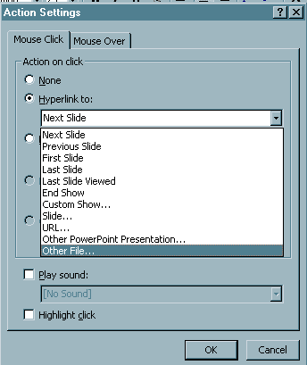
Action Settings
When you click on any object (picture or text), they can become a ‘button.’ This means that an action will happen when you click on it.
1.Select the object (Make sure it has handles)
2. Click on SlideShow>Action Settings
3. Select the Hyperlink to: radio button
4. Click on the triangle
5. Choose from the list.
6. You can add a sound if you like, click on the sound square, click on the magic triangle.

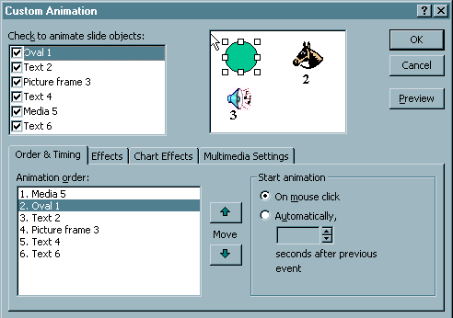
Custom

Animation
It is this window where most of the magic occurs. Here is what you can do:
- Animate any object, select it and choose the Effects tab.
- Determine the order of animation in the Order and Timing tab.
- Make them happen automatically or on a mouse click.
- Determine the time between each animation.
- In the Multimedia Settings you can hide the sound icons.

So, the top window determines whether you want to animate the object by checking the box. The bottom window (Animation order) determines the order that they animate. Change it by selecting the object and clicking on the move arrow. To the right in the Start animation section, you can determine whether it happens magically (automatic) or on a mouse click. The best way to learn is to put some objects on the screen and experiment.

