When the Going Gets Tough, the Tough Put On Suits

By Guy Trebay
New York Times, “Style,” 2003

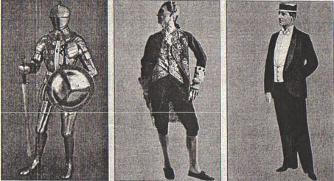
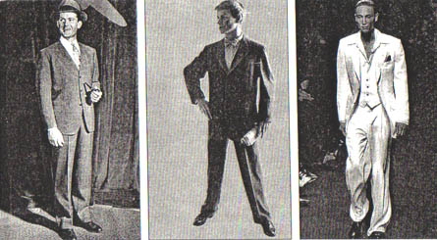
Suits: clockwise: medieval armor, 1780 velvet coat and breeches; 1890 Tailor’s model of the tuxedo; 1942 No collar, lapels or pockets; 1950s The gray flannel suit; 2003, Tom Ford for Saint Laurent
Back in the heady days when the Dow hovered at 10,000 and investors careered on the Nasdaq with the adrenaline thrill of riders on the Coney Island Cyclone, the time-tested boundaries between the public and private selves in business got weirdly blurred. People began to conflate what the sociologist Erving Goffman labeled the "backstage" and "outside regions" in the theater of the self. They moved the unconstrained self to center stage — to the office, the boardroom, the interview.
They slipped out of what Mr. Goffman called the "situational harness" of business uniforms, the kind that clearly convey what you do. Corporate officers dressed for work in gym sweats. Bankers turned up at the office dressed for golf. Even presidential candidates lost track of the symbolism that used to come in every politician's starter kit I and began campaigning dressed like the guy who mows your lawn. But tough times call for legible dressing. Tie sales are now stronger than they have in been in years. The suit is back for men, goes the chorus, as people flock for safety to a uniform that evolved from court dress in the days of Charles II, in 17th-century England. Over the next 200 years, it shed it's aristocratic trappings and morphed into what Andrew Bolton, the associate curator of the Costume Institute at the Metropolitan Museum of Art, called a "democratic, urbanized garment to clothe an ever-expanding middle class."
That class has been pummeled lately, left with diminished portfolios, elusive retirement prospects and, as it turns out, nothing to wear at the office or when looking for jobs. "The main trend we're seeing is the return to dress furnishings and dress clothing," said Michael Ostrove, the general merchandising manager for furnishings at Paul Stuart, the family-owned Madison Avenue haberdashery. Mark Shulman, the chief operating officer for Retail Brand Alliance, which owns Brooks Brothers, said, "Men are dressing up for work again."
Starting Sept 3, in fact, the men among the 3,000 employees of Deutsche Bank in London will have to ditch the sartorial style that an internal memorandum dubbed "clubbing attire" and go back to the one that scholars say has symbolized self-restraint, efficiency and the specialized skill sets called white-collar work since the rise of urbanism in the 19th century. They will return to the suit.
In an e-mail message to employees, Mark Perron, the chief operating officer of the bank's global markets units, noted that a number of Deutsche Bank's rivals had already altered their dress codes. He called a stop to the jeans, khakis, T-shirts and sneakers that were among the last remaining souvenirs of the dot-com boom. "As an organization that prides itself on focus," Mr. Perron wrote, "we can do no less."
Mr. Perron echoed an observation increasingly common in all kinds of offices — not just those where the boss shops on Saville Row. "We feel," Mr. Perron wrote, "there has been a significant shift over the past 18 months among our clients regarding dress code."
Embattled times, in other words, call for suitable armor, a reality both Al Gore and George W. Bush embraced with alacrity when American fears of a constitutional crisis sent both of them racing to the closet to switch their turtlenecks and cowboy jackets for something that said Leader of the Free World.
Both men already owned suits, of course, unlike a good percentage of the public, who had been lulled into thinking of the suit as fashion's dodo, something never again to be seen. "You could afford to be a little more casual when the economy was fat," said Mr. Shulman of Brooks Brothers. "You were not as worried about your job and how you looked." Now, he added, "a lot of people are out of work and have to look for employment." And not many of those people are likely to turn up for a job interview in Dockers and running shoes.
“People have been predicting the end of the suit for as long as I've been in the fashion business," said Alan Flusser, the author of "Dressing the Man: Mastering The Art of Permanent Fashion" and a believer in the Wildean aphorism that "a well-tied tie is the first serious step in life."
It's certainly true that death and resurrection of the suit is a stock story in the rag trade. And it's just as true the suit has rarely, in the centuries since its inception, been in serious danger of losing its hegemony. With the possible exception of the unstitched dhoti, few garments have enjoyed a longer continuous run. It arose as a replacement for the padded doublet that itself held the fashion for 300 years. The breeches worn beneath the newly loosened coat lost their lacing and began to be worn capacious and low. A waistcoat was inserted behind the opening of the coat and, as the art historian Anne Hollander noted, "The three-piece suit was born."
Social critics, whenever they focused on it, tended to deride the suit as "imperial" in its ideology. Yet, the truth is that for at least a century the suit has been the workaday uniform for a vast global middle class. For starters, no one has yet come up with a garment that democratizes the body better by concealing disparities in the male anatomy. And no one has devised a better way to ensure that, as Clifford Grodd, the president of Paul Stuart, observed, the "naked ambition" of the workplace is kept under suitably neutral wraps.
"The big problem with casual Friday," as one refugee of Silicon Valley recently put it, "was that people always knew you were making a career move because you had to put on a suit."
So far, nothing "has come along to replace the formality of a proper dress shirt, a necktie and a business suit," said Mr. Flusser. Not even the space-age coveralls that Pierre Cardin once prophesied as the uniform of the 21st century.
No garment, it turns out, has proved more durable, flexible or forgiving. It is flattering besides. "A suit is obviously a more youthful costume," noted Ms. Hollander, the author of "Sex and Suits: The Evolution of Modern Dress." "This is a truth the female sex learned a long, long time ago from Chanel."

