Phil 2: Introduction to Ethics (Online)
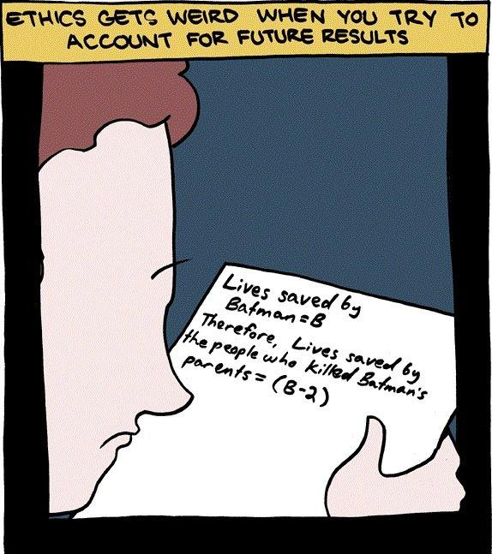
Phil.2 | 3 Credit Hours |
Instructor Information
Instructor | Email
Dr. Garret Merriam | merriam@csus.edu

Student Drop-In Hours: MW, 1:30-2:45 pm, and by appointment, via Zoom. Just as in an in-person class, these hours are there to help you out. Much of this material will be challenging and the best way to get the most out of the class is to reach out to me whenever you have any difficulty. For the link to Zoom meeting, click here or see the Canvas for the course.

Course Description: Examination of the concepts of morality, obligation, human rights, and the good life. Competing theories about the foundations of morality will be investigated. This course explores the major problems and questions of moral philosophy by applying various ethical theories and principles to historical and contemporary moral dilemmas.

Learning Objectives: Upon completion of the course, each student should be able to:
- Identify key concepts and arguments pertaining to the major moral theories and moral controversies.
- Apply those moral theories to novel circumstances.
- Contrast strengths/weaknesses of major arguments on controversial topics.
- Develop creative solutions to novel, challenging moral problems.
- Question/Challenge their own ideas about moral controversies.
- Debate core points of moral controversies.

This course satisfies the Humanities (Area C2) General Education/Graduation requirement.
Readings: All readings will be posted on Canvas in PDF or DOC format.

Weekly Assignments: Most weeks will have two assigned readings. For every reading there will be four key assignments you need to do. (1) Read the essay (~5-10 pages per reading). (2) Take the reading quiz for the essay. (3) Watch the video lecture for the essay. (4) Participate in the discussion board for the week (covers both readings.)

Grading
Learning Activities | Due | Value (pt) | Percentage (%) | Letter Grading
Discussion Boards | Weekly | 150 | 15 | A = 93-100%
Quizzes | 2X Weekly | 250 | 25 | A- =92-90%
4-Sentence Papers | 2/16 & 3/29 | 25 (each) | 5 (total) | B+ = 89-87%
Midterm | Week of 3/4 | 60 | 6 | B = 86-83%
Paper Outline | 4/19 | 50 | 5 | B-=82-80%
Long Paper Final | 5/3 | 250 | 25 | C+ = 79-77%
Final Exam | Week of 5/13 | 190 | 19 | C = 76-73%
Total Points |  | 1000 | 100 | Etc.
Assessments
Reading Quizzes: Each week there will be short quizzes on the readings. Each quiz will be 5 questions long, worth 2 points each for a total of 10 points. The purpose of the quiz is to make sure you’ve done the reading, and will focus on the basic facts in the reading. The quizzes are open book, open notes. You will have 15 minutes to complete the quiz.

Discussion Forums: Since this is an online class participation in the online discussion forums is essential. For each week you will get a grade of 0-10 points for your participation in the discussion boards. As the name suggests, the boards should be about a dialogue between members.

To get full credit you MUST POST AT LEAST TWICE: first your thoughts in reaction to the reading, and second in reaction to someone else’s post. I’m looking to see that your posts are (a) relevant to the reading/topic at hand, (b) substantive (i.e.—more than just a single sentence) and (c) demonstrate that you’ve read the text, watched the video lecture, and thought about the topic. When responding to what other people have said you can agree or disagree with them, but either way you should ask questions, challenge them, try to get them to think more about the topic. Just saying ‘I agree with you, great post!’ in your response doesn’t cut it. One of the most common problems is thin, weak replies to other students that don’t engage with their thoughts in any serious way.

While there is no formal word count, posts less than 200 words or so are very unlikely to get full credit, as it is hard to demonstrate detailed consideration of the reading in such a short length. I want to see that you’re really thinking about the material.

Four Sentence Papers: These are two short writing assignment designed to prime you for writing the argumentative paper. You will pick one of the readings and write a paper based on the following template: “They say…; I say…; One might object…; I reply…” A more detailed explanation of the assignment will be posted on Canvas.

Midterm: The midterm will give you a sense of how well you have been following the material in the course. It is a relatively low-stakes exam that will hopefully let you know how well you’ve been absorbing and remembering the content. It will also give you a preview of the final exam.

Paper (Outline): A 1-page outline describing how you imagine your long paper will proceed. It should specify (1) your thesis statement, (2) a short summary of the reading(s) you’re responding to, (3) your own original argument in response to the reading(s), (4) a charitable objection to your argument on behalf of someone who might disagree, and (5) your response to that objection. (Note: you do not have to stick to this outline in your final draft of the long paper, but your goal should be to have an outline that you can use to draft your long paper.)

Long Paper: You must write be at least 1200 words (about 4 pages, double-spaced), ideally building off of the outline above. You will need to demonstrate both an understanding of what you’ve read and an ability to think about it and criticize it in your own terms. There will be a lecture dedicated to how to write a philosophy paper. There will be sign-ups for the precise due date.

Final: The final will be relatively difficult will require not only familiarity with the material but the ability to use the material to draw practical conclusions from it. You will be expected to have read and studied the readings and will be tested on the material in them, as well as issues that come up in the lectures. There will be a final review beforehand to help you study.

AI and Academic Misconduct: Using an AI text generator for any class assignments, unless the instructor specifically instructs otherwise is dishonest and will be considered a violation of the CSUS Academic Honesty policy here. Submitting any course assignments or prompts to an AI text generator and then submitting the results or any altered form of the results for credit for the assignment in class unless specifically instructed to do so by the instructor will be considered plagiarism, and it could be subject to the full range of sanctions outlined in the university policy.

In addition to using TurnItIn, this course may use rapidly evolving technology (like this) to help detect when student writing has been assisted by AI technology (like Chat GPT). Improper use of AI technology can be grounds for a charge of plagiarism or other academic misconduct, leading to academic penalties (like failing a course) and administrative penalties (like expulsion from the university), regardless of when the academic misconduct is discovered. It is likely that, in the arms race that is digital technology, what seems like today’s detection-proof AI writing tool will be easy to detect by tomorrow, or next week, or next month.

The use of assistive technologies and websites, such as Chegg, Quizlet, and Course Hero are prohibited. If you are discovered using them (and it is not as hard to discover as you might think) you will be reported both to the Department Chair and the Office of Student Conduct for possible further administrative sanction.

Should you be caught cheating on a paper, quiz, discussion post or an exam, this may be grounds for your immediate failure of the course. ALL incidents of cheating and plagiarism will be reported both to the Department Chair and to the Judicial Officer in the Office of Student Affairs for possible further administrative sanction.

Late Work Policy: I am willing to give short extensions on assignments, provided the request is made BEFORE the due date. Otherwise, no late assignments will be accepted.
To prove that you read the syllabus: Beneath the syllabus posting on Canvas there is a tab labeled “Did you read the syllabus?” Click on it and attach a picture of a pet (cat, dog, etc.) I will not grade any of your assignments until you complete this task.

Student Health & Counseling Services: Due to the current and ongoing events faced by many during this public health crisis and era of civil unrest, the University recognizes that many of you may be in need of support. Please be aware that Health and Counseling Services staff are available for virtual and in-person services.

Additionally, if you are experiencing any COVID-like symptoms (fever, cough, sore throat, muscle aches, loss of smell or taste, nausea, diarrhea, or headache) or have had exposure to someone who has tested positive for COVID contact Student Health & Counseling Services (SHCS) at 916-278-6461 to receive guidance and/or medical care. You are asked to report any possible COVID-related illnesses or exposures to SHCS via this link COVID-19 Illness/Exposure Report Form. You should expect a call from SHCS within 24 hours.

Reasonable Accommodations: If you have a documented disability (visible or invisible) and require accommodation or assistance with assignments, tests, attendance, note taking, etc., please contact me by the end of the third week of semester so that arrangements can be made. Failure to notify and consult with the instructor by this date may impede my ability to offer you the necessary accommodation and assistance in a timely fashion. Also be sure to consult with the Services to Students with Disabilities in Lassen Hall to see what other campus services and accommodation options are available for you.

Students with other types of accommodation requirements, such as English as a second language, are invited to discuss them with me to facilitate understanding and the best learning experience for all. All information will remain confidential.

Contact Information for the Department Chair: If you have a problem with either the class or with me I would appreciate it if you talked to me about it first. But if you feel you cannot talk to me for some reason, you can talk to my department Chair, Dr. Russell DiSilvestro at rdisilv@csus.edu.

Reading Schedule for the first weeks (will be updated after applied topics are voted on):
Week of 1/22—Intro and Virtue Ethics
- Opening and Greetings; Syllabus, Course Overview
- “How to Be Perfect (Introduction)”—Michael Schur
- “Should I Punch My Friend in the Face for No Reason?”—Michael Schur

Week of 1/29—Utilitarianism & Kantianism
- “Should I Let This Runaway Trolley I’m Driving Kill Five People, or Should I Pull a Lever and Deliberately Kill One (Different) Person?”—Michael Schur
- “Should I Lie and Tell My Friend I Like Her Ugly Shirt?”—Michael Schur
Week of 2/5—Metaethics: Relativism and Divine Command Theory
- “Relativism in Ethics”—William Shaw
- “Morality, Religion and Conscience”—John Arthur

