**Spring 2025 Syllabus**

**for PHIL.199: *Bioethics Bowl***

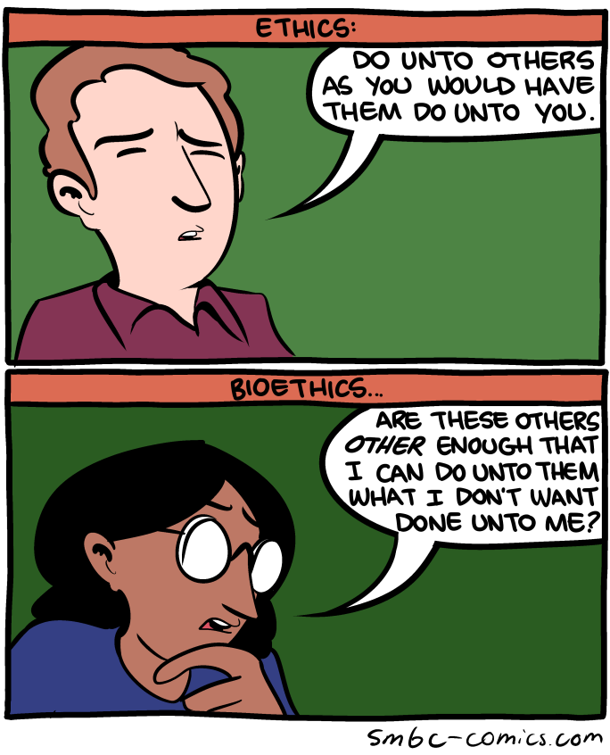

Class time and location: MW 12-1:15 pm, Mendocino 3009

Instructor: Dr. Garret Merriam

Office Location: Mendocino 3028

Office Phone: 916-278-7588

Office hours: MW 1:30pm-2:45pm and by Appointment

Email Address: merriam@csus.edu

**Course Description**: Bioethics Bowl is a national academic competition. Schools organize teams of 5-6 students and practice verbal debate over a series of assigned cases of moral dispute in clinical and medical research. Preparation for each case involves researching relevant history, medicine, and moral theories, anticipating potential questions, organizing arguments in response to those questions, considering counterpoints and replying to them, and practicing delivering all of these from memory in a structured debate format.

**Learning Objectives:** Upon completion of the course students should be able to:

1. Research morally complicated topics using academic sources.
2. Consider morally challenging cases from multiple perspectives.
3. Work with a team to organize and refine a rationally compelling oral argument drawing on research, moral theory and competing perspectives.
4. Deliver an oral presentation to a panel of judges in a timed, structured format involving objections from the competing team, and questions from the judges.

**Assessments**

**Research write ups:** For each case you are primary or secondary on you will need to do background research. That should begin by investigating the sources given in the case itself but should also include more sources that you dig up on your own. You will be sharing your sources to the google docs file for the relevant case, along with a short summary of the key points of each source. These can be updated over the semester but must be completed before the competition.

**Written Case Prep:** Each case will require a crafted, structured argument anticipating different possible questions, and highlighting 2-3 main arguments on both sides of the issue. This write up will be the basis for the oral presentation, so it should be clear, organized, and comprehensive. You will share them on the google docs file for the relevant case. These can be updated over the semester, but a first draft should be posted 24 hours BEFORE the first class where we address the case so the rest of the team has time to look it over before practice.

**Feedback to Team Members:** Your team members rely on you to backstop them, notice flaws in their arguments, help them improve their presentation. When the case being discussed is one where you’re neither primary nor secondary on you will be required to give them feedback to those who are.

**Weekly In-Class Performance:** “Practice the way you play, because you will play the way you practice.” Everyone needs to come to class prepared to do their party, every week. If you drop the ball, the rest of the team suffers. This means you need to look over the notes for the cases we are covering before class, and be ready to present your part of the case in practice.

**Recorded Test Runs**: For each case that you are primary on you must record a live, real-time practice run of your full case. You can submit this any time (and multiple times, but at least once) before the competition, but I recommend submitting it about two weeks before.

**1-Page Case Summary**: 1 week before Game Day you will need to take the Google Doc for each case you are primary on and condense it down to a 1-page executive summary. This should act like a cheat sheet that the whole team can quickly look over, to see the case at a glance.

**Grade Breakdown:**

Research Write Ups: 100 points

Written Case Prep: 200 points

Feedback to Team Members: 100 points

Weekly In-Class Performance: 200 points

Recorded Test Runs: 200 points

1-Page Case Summary: 200 points

Total: 1,000 points

Your final grade will be determined by the number of points you have out of a

possible 1000. You will be graded on a fixed scale rather than a curve: A = 93-

100%; A- = 92-90%; B+ = 89-87%; B = 86-83%; B- = 82-80%; C+ = 79-77%; C =

76-73%; C- = 72-70%; D+ = 69-67%; D = 66-63%; D- = 62-60%; F = 59-0%.

**Attendance Policy:** This is a team competition. Your teammates are relying on you to help them make their cases. You can’t do that if you’re not here. If you know you can’t make class, let us know beforehand. We can try to schedule around if we know in advance. Failure to notify us, or chronic absenteeism will result in you being dropped from the class.

**Reasonable Accommodations:** If you have a documented disability (visible or invisible) and require accommodation or assistance with assignments, tests, attendance, note taking, etc., please see the instructor by the end of the third week of the semester so that arrangements can be made. Failure to notify and consult with the instructor by this date may impede my ability to offer you the necessary accommodation and assistance in a timely fashion. Also be sure to consult with the Services to Students with Disabilities (Lassen Hall; <http://www.csus.edu/sswd/index.html>) to see what other campus services and accommodation options are available for you. Students with other types of accommodation requirements, such as English as a second language, are invited to discuss them with the instructors to facilitate understanding and the best learning experience for all. All information will remain confidential.

**Contact Information for the Chair of the Department:** If you have a problem with either the class or with me I would appreciate it if you talked to me about it first. But if you feel you cannot talk to me for some reason, you can talk to my department Chair, Dr. Russell DiSilvestro at [rdisilv@csus.edu](mailto:rdisilv@csus.edu).

**Tentative Schedule**

Week of 1/27: Introduction, overview, rules of the competition,

* General advice and strategy
* First two cases (lose timing, generic question, notes allowed)

Week of 2/3: Next six cases (lose timing, generic question, notes allowed)

Week of 2/10: Last six cases (lose timing, generic question, notes allowed)

Week of 2/17: 2nd pass on six cases (tighter timing, specific question, no notes)

Week of 2/24: 2nd pass on six cases (tighter timing, specific question, no notes)

Week of 3/3: 2nd pass on two cases (tighter timing, specific question, no notes)

* 3rd pass on four cases (game-day timing, specific question, no notes)

Week of 3/4: 3rd pass on six cases (game-day timing, specific question, no notes)

Week of 3/10: 3rd pass on four cases (game-day timing, specific question, no notes)

* 4th pass on two cases (game-day timing, specific question, no notes)

Week of 3/17: 4th pass on six cases (game-day timing, specific question, no notes)

Week of 3/24: 4th pass on six cases (game-day timing, specific question, no notes)

* Dress Rehearsal (possibly against UC Davis)

Week of 3/31: SPRING BREAK

* If possible, 5th pass on problem cases (game-day timing, specific question, no notes)
* GAME DAY: 4/5