- Label the following images using the body regions listed in the table below:
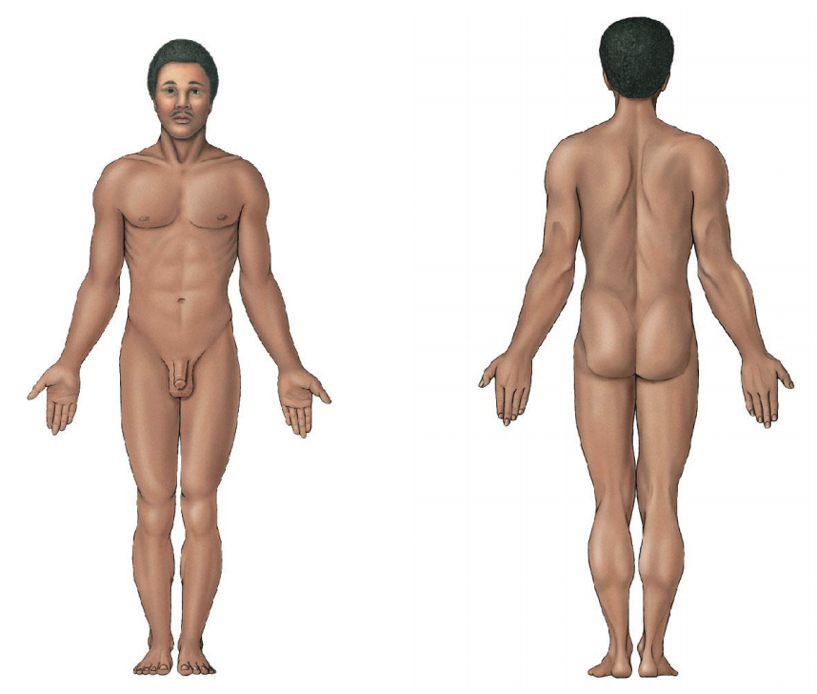

Axial | Head | Upper Limb | Lower Limb
Cervical | Cephalic | Acromial | Gluteal
Thoracic | Cranial | Axillary | Inguinal
Sternal | Facial | Brachial | Femoral
Mammary | Frontal | Antecubital | Patellar
Abdominal | Ocular | Olecranal | Popliteal
Umbilical | Nasal | Antebrachial | Crural
Dorsal | Otic | Carpal | Sural
Lumbar | Buccal | Manual | Tarsal
Pelvic | Oral | Palmar | Calcaneal
Pubic | Mental | Pollex | Pedal
Coxal | Lingual | Digital | Plantar

- Fill in the noun form of each body region and then the English word for each anatomical body region.

Adjective Form | English Term
Cervical
Thoracic
Sternal
Mammary
Abdominal
Umbilical
Dorsal
Lumbar
Pelvic
Pubic
Coxal
Cephalic
Cranial
Facial
Frontal
Frontal
Ocular
Otic
Nasal
Buccal
Oral
Mental
Lingual
Acromial
Axillary
Brachial
Antecubital
Olecranal
Antebrachial
Carpal
Manual
Palmar
Pollex
Digital
Gluteal
Inguinal
Femoral
Patellar
Popliteal
Crural
Sural
Calcaneal
Pedal
Plantar

Adjective Form | Noun Form | English Term
Cervical
Thoracic
Sternal
Mammary
Abdominal
Umbilical
Dorsal
Lumbar
Pelvic
Pubic
Coxal
Cephalic
Cranial
Facial
Frontal
Ocular
Nasal
Otic
Buccal
Oral
Mental
Lingual
Acromial
Axillary
Brachial
Antecubital
Olecranal
Antebrachial
Carpal
Manual
Palmar
Pollex
Digital
Gluteal
Inguinal
Femoral
Patellar
Popliteal
Crural
Sural
Tarsal
Calcaneal
Pedal
Plantar

