# CECConnect: How to submit Recreation, Parks & Tourism Administration (RPTA) Internship Forms

**Contents**

CECConnect: How to submit Recreation, Parks & Tourism Administration (RPTA) Internship Forms 1

Instructions: 3

Getting Started: 3

Step 1: Create a CECConnect account 3

Step 2: New CEC Connect Accounts & Major Placements 4

Step 3: Returning Users/Getting Familiar with CEC Connect 9

Step 4: Completing and Submitting Internship Forms 11

## Instructions:

Prior to submitting any RPTA internship form you must have:

* Completed or are in the process of completing pre-internship hours (Form A)
* Attended a Mandatory Student Internship Meeting with the RPTA Internship Coordinator
* Identified where you will be doing your internship
* Met with your Academic Advisor to discuss your Form A, internship plans, goals and internship agency with your Academic Advisor

## Getting Started:

Many of you may have a CECConnect account already, particularly if you took RPTA 106 and did service learning. To check if you do or if you know you do, skip on to Step: 3 Returning Users/Getting Familiar with CECConnect

Otherwise, start here:

## Step 1: Create a CECConnect account

* Go to: [CEC Connect](https://app.calstates4.com/csus):

https://app.calstates4.com/csus

* On the welcome page click on the “Student/ Faculty Log In” button
* Answer the prompted questions for account registration

Screenshot of:
CEC Connect Welcome Page

## Step 2: New CEC Connect Accounts & Major Placements

* Once logged in, you will see either the “Homepage” or you may be prompted to select a “Program that matches your major”
* If you are taken to the homepage, please skip to: Step 3 Returning Users/Getting Familiar with CEC Connect
  + Do not create multiple placements for your internship, if you need assistance, please email: [mavie.marquez@csus.edu](mailto:mavie.marquez@csus.edu)
* If you are prompted to select a program, make your selection by clicking on the button under your major’s program
  + Major selections:
    - Hospitality and Tourism Management (HTM)
    - Recreation Management (RA)
    - Recreations Therapy (RT)

**screenshot of program selections:
Hospitality and Tourism Management
Recreation Administration
Recreational Therapy**

* Enter required fields
* Check the box to “confirm”
* Click on “Update my account” button

A screenshot of required fields:
legal first Name 
preferred name (optional)
last name
check box to confirm program

* Click on the “Place” button
  + Do Not click “browse”. If you accidentally click” browse”, you will have to go to “Homepage”, then click on the “Place” button

A screenshot:
placing in your major

* Click “Search by Site” button
  + **Note:** “site” in this case indicates you are selecting your placement major program within CEC Connect to access RPTA internship forms. This **does not** mean you are selecting an internship site/agency location.

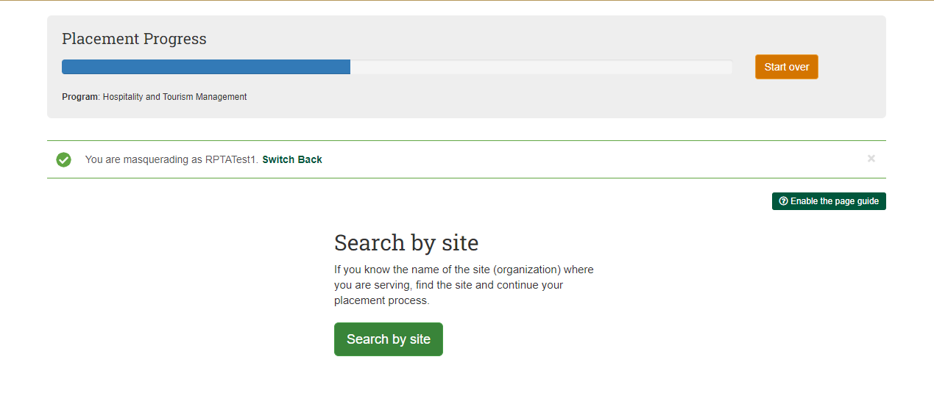

* Search for RPTA Intake Forms
  + In “Site Name” box type RPTA
* Click the “Apply Filter” button
* Click on “RPTA Intake Forms” (green font)

A screenshot: 
Program Site Search/Filter 

* Click on the “Select this site” button

A screenshot:
"Select this Site" button

* Type the term and year that you plan to do your internship in the “Term” box
* Type the anticipated number of hours you will need for your internship in the “hours” box (
  + example: 400 hours for RA & HTM, 560 hours for RT
* Click on the “Next” button.

A screenshot: 
"Term" box
"Hours" box
"Next" button

* Click on the “Finish Placement” button

A screenshot: 
"Finish Placement" button

* Placement to your “RPTA Intake Forms” is now complete
* A “Placement” number is assigned for your program in CEC Connect
* Use this “Placement” number to access, complete and submit your internship forms
  + If you plan to complete and submit your forms later, go to Step 3: Returning Users/Getting Familiar with CEC Connect to find your internship forms again

A screenshot: 
Assigned "Placement" number
Available Internship Forms

## Step 3: Returning Users/Getting Familiar with CEC Connect

If you have already created a CEC Connect account and added the RPTA Intake Forms, you can view your “placement” and internship forms by following these steps:

* Go to “Home” page
* Scroll down and click on “View my placements” (green font)

A screenshot of: 
"View my placements"

On the following page, you can view all your placements for each term. Things to check for:

1. That you have one major placement number
   * If you have more than one, your account will need to be updated prior to submitting any internship forms
   * If you do not have any RPTA major placements, go back and follow the instructions on Step 2: New CEC Accounts & Major Placements
2. That your placement number is under the term that you plan to do your internship
   * If your term is not correct, your account will need to be updated prior to submitting any internship forms
   * To update your account email: [mavie.marquez@csus.edu](mailto:mavie.marquez@csus.edu)

If you have already checked the two items above, continue to view your RPTA Major Placement and access your internship forms

* Click on your RPTA major placement number to access your internship forms (green font)

A screenshot of: 
"placement" number example

* On the following page, you will see the current term internship forms
  + Internship Agreement Form C (RA & HTM majors)
  + Internship Agreement Form D (RT majors only)
  + Agency Contract Form B

## Step 4: Completing and Submitting Internship Forms

* Click “Complete form” for the forms you want to submit
  + You can save a draft of a form you started and come back to complete it later by clicking on the “Save Draft” button at the bottom of your form
    - To access an already started draft email: [mavie.marquez@csus.edu](mailto:mavie.marquez@csus.edu)
    - Do not create multiple placements or open multiple drafts for the same form

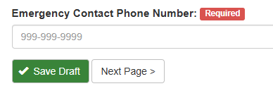

* Prior to submitting forms, ensure that all information is complete and correct
  + Incomplete or incorrect forms may not be processed
  + If you need to update information on a submitted form, email: [mavie.marquez@csus.edu](mailto:mavie.marquez@csus.edu) for further assistance

**A screenshot of:
Available internship forms**