Steps to Using MySQL Databases with ASP.NET

- Install MySQL 5.0 to your computer (use default settings). Program is found in the mysql-5.0.27-win32.zip file (in the download file I provided you).
- Install the MySQL GUI tools from the mysql-gui-tools-5.0-r6-win32.msi file (in the download file I provided you).
- Install the ODBC 3.51 MySQL driver from the mysql-connector-odbc-3.51.12-win32.msi file (in the download file I provided you).
- Restore the database I provided you
  - Open MySQL Administrator and select the Restore object. Then, click the Open Backup File button.
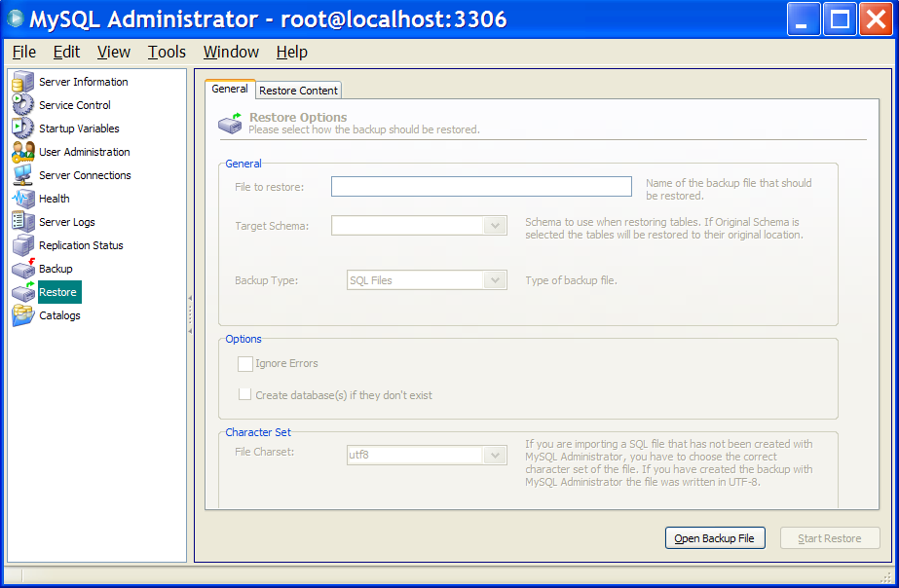
  - Select the backup file I provided you and click the Start Restore button.
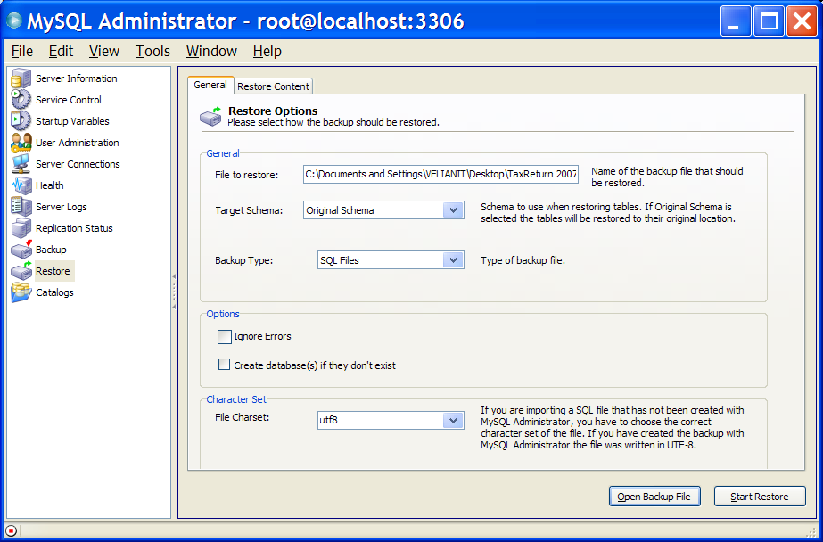
  - Look in the Catalogs. Your database named taxreturn should show.
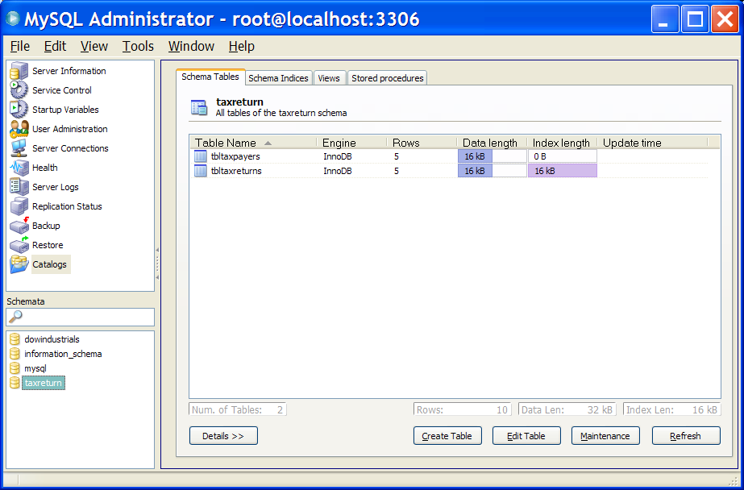
- Register your taxreturn MySQL database with ODBC
  - View your ODBC Administrator program from your Control Panel and select the System DSN tab.
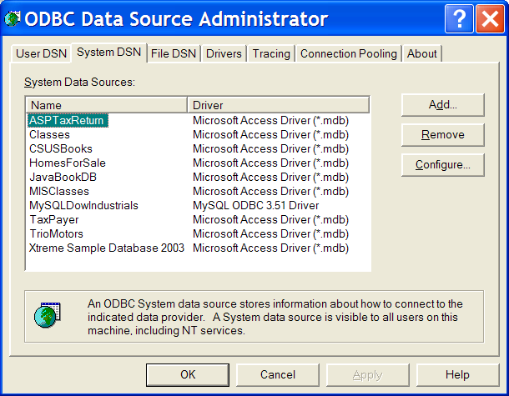
  - Click the Add button and select the MySQL ODBC 3.51 Driver. Click the Finish button.
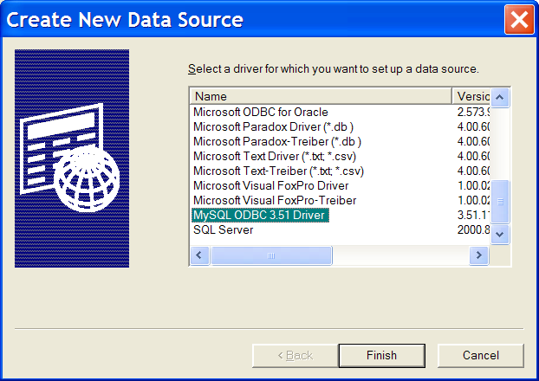
  - Type the information shown below and click on the Test button to test your connection.
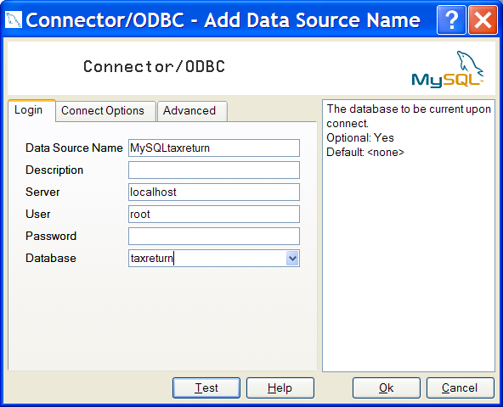
  - Click the Ok button to return to the ODBC Data Source Administrator and exit.
- Use the following connection String in your Visual Studio Web Project:
ConnectionString = "Host=127.1.1.1;DSN=MySQLtaxreturn;PORT=3306;UID=root;DATABASE=taxreturn;OPTION=3"

Handy MySQL Commands
Description | Command
To login (from unix shell) use -h only if needed. | [mysql dir]/bin/mysql -h hostname -u root -p
Create a database on the sql server. | create database [databasename];
List all databases on the sql server. | show databases;
Switch to a database. | use [db name];
To see all the tables in the db. | show tables;
To see database's field formats. | describe [table name];
To delete a db. | drop database [database name];
To delete a table. | drop table [table name];
Show all data in a table. | SELECT * FROM [table name];
Returns the columns and column information pertaining to the designated table. | show columns from [table name];
Show certain selected rows with the value "whatever". | SELECT * FROM [table name] WHERE [field name] = "whatever";
Show all records containing the name "Bob" AND the phone number '3444444'. | SELECT * FROM [table name] WHERE name = "Bob" AND phone_number = '3444444';
Show all records not containing the name "Bob" AND the phone number '3444444' order by the phone_number field. | SELECT * FROM [table name] WHERE name != "Bob" AND phone_number = '3444444' order by phone_number;
Show all records starting with the letters 'bob' AND the phone number '3444444'. | SELECT * FROM [table name] WHERE name like "Bob%" AND phone_number = '3444444';
Use a regular expression to find records. Use "REGEXP BINARY" to force case-sensitivity. This finds any record beginning with a. | SELECT * FROM [table name] WHERE rec RLIKE "^a$";
Show unique records. | SELECT DISTINCT [column name] FROM [table name];
Show selected records sorted in an ascending (asc) or descending (desc). | SELECT [col1],[col2] FROM [table name] ORDER BY [col2] DESC;
Return number of rows. | SELECT COUNT(*) FROM [table name];
Sum column. | SELECT SUM(*) FROM [table name];
Join tables on common columns. | select lookup.illustrationid, lookup.personid,person.birthday from lookup  left join person on lookup.personid=person.personid=statement to join birthday in person table with primary illustration id;
Switch to the mysql db. Create a new user. | INSERT INTO [table name] (Host,User,Password) VALUES('%','user',PASSWORD('password'));
Change a users password.(from unix shell). | [mysql dir]/bin/mysqladmin -u root -h hostname.blah.org -p password 'new-password'
Change a users password.(from MySQL prompt). | SET PASSWORD FOR 'user'@'hostname' = PASSWORD('passwordhere');
Switch to mysql db.Give user privilages for a db. | INSERT INTO [table name] (Host,Db,User,Select_priv,Insert_priv,Update_priv,Delete_priv,Create_priv,Drop_priv) VALUES ('%','db','user','Y','Y','Y','Y','Y','N');
To update info already in a table. | UPDATE [table name] SET Select_priv = 'Y',Insert_priv = 'Y',Update_priv = 'Y' where [field name] = 'user';
Delete a row(s) from a table. | DELETE from [table name] where [field name] = 'whatever';
Update database permissions/privilages. | FLUSH PRIVILEGES;
Delete a column. | alter table [table name] drop column [column name];
Add a new column to db. | alter table [table name] add column [new column name] varchar (20);
Change column name. | alter table [table name] change [old column name] [new column name] varchar (50);
Make a unique column so you get no dupes. | alter table [table name] add unique ([column name]);
Make a column bigger. | alter table [table name] modify [column name] VARCHAR(3);
Delete unique from table. | alter table [table name] drop index [colmn name];
Load a CSV file into a table. | LOAD DATA INFILE '/tmp/filename.csv' replace INTO TABLE [table name] FIELDS TERMINATED BY ',' LINES TERMINATED BY '\n' (field1,field2,field3);
Dump all databases for backup. Backup file is sql commands to recreate all db's. | [mysql dir]/bin/mysqldump -u root -ppassword --opt >/tmp/alldatabases.sql
Dump one database for backup. | [mysql dir]/bin/mysqldump -u username -ppassword --databases databasename >/tmp/databasename.sql
Dump a table from a database. | [mysql dir]/bin/mysqldump -c -u username -ppassword databasename tablename > /tmp/databasename.tablename.sql
Restore database (or database table) from backup. | [mysql dir]/bin/mysql -u username -ppassword databasename < /tmp/databasename.sql
Create Table Example 1. | CREATE TABLE [table name] (firstname VARCHAR(20), middleinitial VARCHAR(3), lastname VARCHAR(35),suffix VARCHAR(3),  officeid VARCHAR(10),userid VARCHAR(15),username VARCHAR(8),email VARCHAR(35),phone VARCHAR(25), groups  VARCHAR(15),datestamp DATE,timestamp time,pgpemail VARCHAR(255));
Create Table Example 2. | create table [table name] (personid int(50) not null auto_increment primary key,firstname varchar(35),middlename varchar(50),lastname varchar(50) default 'bato');

