Cosumnes Community Services District

Parks and Recreation Department
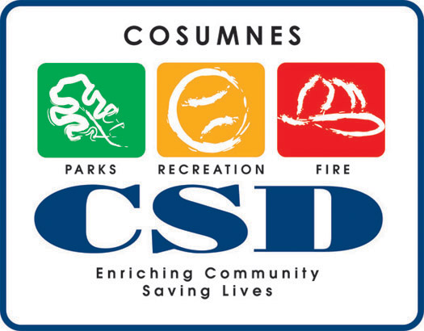

JOB ANNOUNCEMENT

Recreation Leader III (Part-time)
Therapeutic Recreation

Under supervision, typical duties will include facilitating programs and activities; supervising participants; preparing needed supplies and materials for programs and activities; answering questions from customers.

MINIMUM TRAINING AND EXPERIENCE

Knowledge of: principles and practices of customer service; effective practices in facilitating recreation activities; workplace safety, especially as it relates to the program; basic office methods and procedures.

Must have a high school diploma or equivalent and be 18 years of age. Experience working in therapeutic recreation is preferred. Fingerprinting Required.

Work Site Location: 9014 Bruceville Road, Elk Grove, CA. 95758
Starting Date of Employment: September 1, 2007
Hours: 20 hours per week Weekend and evening work required

Starting Compensation: $10.05 per hour

APPLICATION: Available at Cosumnes Community Services District (CSD), Suite 3, Parks and Recreation Department or download from our website: www.yourcsd.com.

Send completed application to:

James Lutz
Cosumnes CSD
Parks & Recreation Department
9014 Bruceville Road
Elk Grove, CA 95758
(916) 405-5605

Application deadline: Open until filled.

