Art of the African Diaspora
Michael Harris

With the American Negro his new internationalism is primarily an effort to recapture contact with the scattered peoples of African derivation.
Alain Locke, “Enter the New Negro,” 1925

Long before modern art appeared on the African continent it had been produced by artists of African descent in the Americas. This essay by African-American art historian Michael Harris tells the story of African-American art, focusing on United States artists and modern art centered in the New York City neighbourhood of Harlem in the 1920s and 1930s. But the art of the African diaspora reaches much farther geographically and chronologically, with dates that correspond to the half-millennium age of Europe and the wholesale European colonization of the Americas. Less than a decade after the 1492 Encounter on Hispaniola, the Atlantic slave trade began to take uncounted millions of people out of Africa to forced labor in the Americas. The Atlantic trade in slaves lasted around four centuries, ending in the third quarter of the nineteenth century. Throughout the American hemisphere during the age of Europe, African, indigenous, European, and Asian cultures mixed promiscuously – despite epic-scaled destruction of traditions and inequalities of power – to form the world-influential “American” hybrids of global modernisms. For the influence of African diaspora cultures on Latin American modern art, see “Africa in the Art of Latin America” by Gerardo Mosquera in this volume.

As you read this selection by Michael Harris, keep in mind the astonishing reversal behind the art of the African diaspora. Robert Scott Duncanson, for instance, who began an international career as a Romantic landscape painter as early as mid-19th century, was the grandson of a slave. From an utterly degraded identity as members of a race of slaves, African-American intellectuals, writers, and artists contributing to the so-called Harlem Renaissance invented a race of culture bearers, “progenitors of the great art traditions of Africa.” What made this possible?

Among many factors, perhaps the first is that most artists of the African diaspora and Harlem Renaissance were educated cosmopolitans, internationalists who spent time in Paris and other cosmopolitan centers. They discovered African art and the racial pride that went with it through exposure to Western collections of traditional African art. Artist Hale Woodruff (1900-1980), for example, the last to be considered in this selection, testified that his first encounter with African sculpture was in an art book “written up in German, a language I didn’t understand! Yet published with beautiful photographs and treated with great seriousness and respect! Plainly sculptures of black people, my people, they were considered very beautiful by these German experts! The whole idea that this could be so was like an explosion in me.” The book that filled him with enthusiasm, Carl Einstein’s Negerplastik (1915), was in fact the first in which pre-modern African art, previously looked upon as ethnographic objects, was recognized as art.

A second reason is that primitivism – avant-garde modern art inspired by long-established visual culture traditions – especially valorized traditional African sculpture, which was newly available by 1910 for re-appropriation by African diaspora artists who sought an “authentic African” identity. The quest for the self untainted by urban modernity inspired them. In this way, Afro-Asian-Cuban Wifredo Lam (1902-1982) appropriated traditional African forms much like Picasso and Surrealist artists of the School of Paris. Such artwork has been considered a visual counterpart to the writings of Aimé Césaire (1913-2008). Modernist “European” values are internalized in such works, but questioned from different artistic perspectives and forming unique modern syntheses.

Questions for reading: Considering information from other articles in this section, how do the circumstances and attitudes of African diaspora artists compare with those of modern African artists on the continent itself? Why did modern art on the African continent not appear in earnest until the independence era following World War II? In what ways does the globalism of African diaspora art prefigure 21st century art?

Source: Michael Harris, “Art of the African Diaspora”, in A History of Art in Africa, 500-514. London: Harry N. Abrams, 2000.

Suggestions for Further Reading:

Alain Locke,” Art of the Ancestors,” Survey Graphic, Harlem Number, March, 1925.

Romare Bearden and Harry Henderson, A History of African-American Artists. From 1792 to the Present, New York: Pantheon Books, 1993.

Mary Schmidt Campbell, Harlem Renaissance: Art of Black America, Studio Museum in Harlem, New York: Harry N. Abrams, 1987.

Martha Jane Nadell, Enter the New Negroes: Images of Race in American Culture, Cambridge: Harvard U P, 2004.

Regenia A. Perry, Free Within Ourselves: African-American Artists in the Collection of the National Museum of American Art, Washington DC: Smithsonian Institution, 1992.

Africans were taken into slavery and shipped across the Atlantic from early in the sixteenth century until the second half of the nineteenth century, with nearly half being transported during the eighteenth century. Approximately 14 million Africans survived the Atlantic crossing and, though they left their material culture behind, they were cultural beings who carried inside them various ways of approaching and interpreting life. Congregated in the New World, they formed communities and developed new means of meeting the same expressive and artistic needs they had felt in Africa. In some cases, Africans speaking the same language from the same cultural group were gathered together on plantations, especially in the Caribbean and in Brazil, and recognizable cultural practices from their home land were revived and continued. Often cultural influences from several areas of Africa melded together. The Haitian religious practices known as Vodou, for example, combine Yoruba, Kongo, and Dahomean elements. In the United States, slaveowners, fearing rebellions, made an effort to group together Africans of varying cultural and linguistic backgrounds in order to suppress communication and collaboration. Still, Africans found what was most common among them and expressed themselves in ways reminiscent of their home cultural practices, though perhaps in more general ways. (…) After slavery was abolished, the continued existence of racism affected the aspirations, status, and consciousness of black people. The social restrictions and obstacles they faced affected the production of art, and it is useful to consider these social and historical factors when looking at the work of African American artists. The making and appreciating of fine art in European contexts was a middle- or upper-class activity. The social and economic oppression faced by blacks made it difficult to pursue this kind of art as a career prior to the second half of the twentieth century. Folk expression, however, was less encumbered by racism, and in fact may have flourished in part because segregation left black communities more intact socially to develop as subcultures. (…)
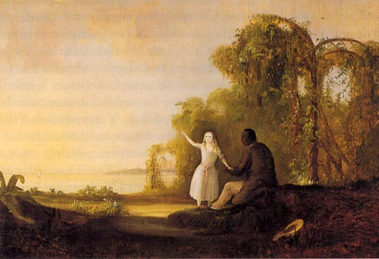
1. Robert Duncanson, Tom and Little Eva, 1853, oil on canvas, 27¼ x 38¼ in., Detroit
Speaking Through New Forms

(…) One of the first accomplished African American painters was Robert Duncanson (1823-1872), a man of mixed race who resided for most of his adult life in the Cincinnati area. Duncanson exhibited the broad range of atmospheric and emotional elements in his work typical of the style of American landscape painting known as the Hudson River school, but few of his works included African American subjects. (…)

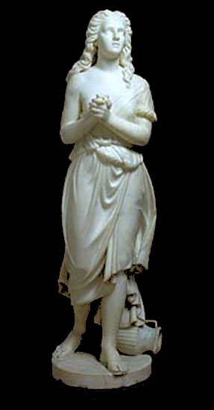
It is difficult to say how much Duncanson identified with his African heritage, but he lived during a time when there had been several riots in Cincinnati in which whites attacked blacks, and pro-slavery advocates had a strong presence there despite the fact that Ohio was not a slave state. Most indications are that he acknowledged his racial designation but chose not to address issues around that identity in his work other than in one painting, Tom and Little Eva, inspired by Harriet Beecher Stowe's abolitionist novel Uncle Tom's Cabin.
2. Edmonia Lewis, Hagar, 1875, marble, Height 52 in., National Museum of American Art, Washington, D.C.

Edmonia Lewis (c. 1843-1909) was the first woman artist of African descent to gain prominence in the United States. Details about her life are sketchy, but she was born to African American and Chippewa parents. Lewis attended Oberlin College for a while before being forced to leave after a highly publicized trial in which she was accused of poisoning two of her roommates, and subsequent accusations that she had stolen art supplies. (…)

She settled in Rome in 1866 and developed her academic Neoclassical style there. One of her most notable works in this mode, and one of the few that survive, is Hagar. Lewis dealt with racial themes and subjects in her work more directly than most nineteenth-century artists of African descent, and Hagar illustrates how she pursued these themes with subtlety and allusion. (…)

Hagar is an African woman (despite the Neoclassical mode of presentation), a slave, and she was victimized by sexual liaisons with her master; a string of circumstances which directly related to the plight of many black women in the New World. The work was created at a time when blacks were being re-enslaved by the collapse of Reconstruction in the American South, and black women still were vulnerable to sexual exploitation due to disparities in power between whites and blacks. In Brazil, where the great majority of Africans taken in the Atlantic slave trade had been sent, the end of slavery was still over a decade away. Lewis's imagery was not black, but clearly her subject matter related to the experiences of many black women. (…)

In 1893, at the same time as the World's Columbian Exposition in Chicago, blacks from Africa, the Caribbean, and the United States convened the Congress on Africa, possibly the first pan-African meeting. In attendance was Henry O. Tanner (1858-1937), the most accomplished and prominent African American artist of his time. That same year, Tanner completed one of the few genre paintings of his career, The Banjo Lesson. (…) The Banjo Lesson presents a tender exchange between an elder and a youth, alluding to an educational tradition of inter-generational exchange in which folklore and lessons were handed down. (…)
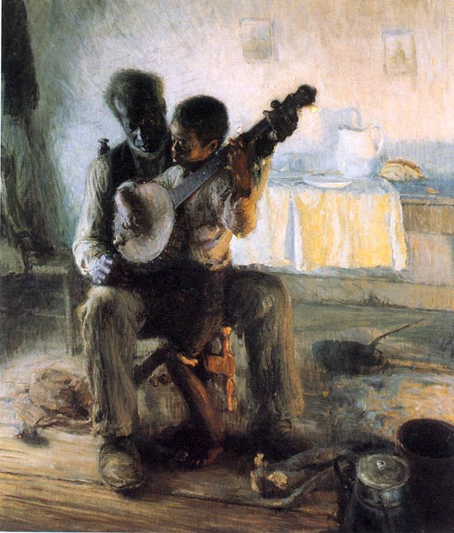
3. Henry O. Tanner, The Banjo Lesson, 1893, oil on canvas, 49 x 35 in, Hampton University Museum
The sculpture Ethiopia Awakening by Meta Warrick Fuller (1877-1968) can be seen as an extension of Tanner's painting. Fuller's work allegorically depicts a woman emerging from a deep, mummified sleep into lively animation. The lower portion of her body is still wrapped as if entombed, but the upper torso has begun turning and waking from a metaphorical sleep. The work also suggests a butterfly forcing its way out of a cocoon into a new life.
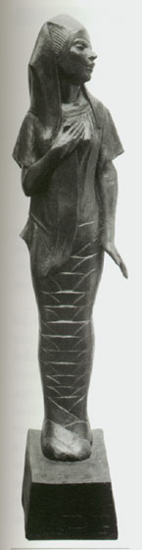
4 Meta Vaux Fuller, Ethiopia Awakening, c1907-14 bronze, 5’7” Height, New York Public Library, Schomburg Center
Ethiopia – from an ancient Greek word meaning the land of the "sun-burnt people" – was a term that embraced a variety of African peoples found in Egypt, Libya, Nubia, or Kush, down into the region of the present-day nation-state of Ethiopia. The term had long been applied to signify things African or black in American parlance - minstrel performances often were called Ethiopian operas – and Fuller uses it in this way here.

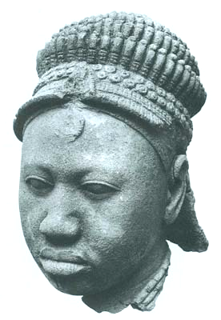
Fuller, who like many prominent African American artists of the era studied in Europe, worked in a narrative style. Her work, like that of Edmonia Lewis, suggested African themes and used Egypt as a synonym for Africa. With Ethiopia Awakening, however, the focus of Fuller's work moved beyond slave or plantation references toward a pan-African imagination. She linked the growing self-consciousness and self-confidence of African Americans with global trends, and her implication that racial identity was the equivalent of national identity as a means for unity in a common cause reflected the ideas of W. E. B. Du Bois (1868-1963), an eminent African American intellectual and one of the co-founders of the National Association for the Advancement of Colored People (NAACP).
5. Head of a Queen. Yoruba. Ife, Nigeria. 12th-15th c., terracotta, 9 5/6 in

Reclaiming Africa
The last decade of the nineteenth century and the first several of the twentieth century witnessed a number of significant events and trends which radically affected African consciousness for the remainder of the twentieth century. The 1893 Chicago Congress on Africa was followed by the formation of the African Association by Trinidadian Henry Sylvester Williams in England in 1897, and a Pan-African Congress in 1900 in England. The sacking of Benin by the British Punitive Expedition in 1897 led to thousands of African art objects appearing on the market. German ethnographer Leo Frobenius stumbled upon the Ife heads during the first decade of the twentieth century, and their naturalism challenged erroneous assumptions that African art was unintentionally abstract because of an inherent African inability to produce naturalistic work. The growing interest in African art as art shown by European avant-garde artists contributed to an increased scrutiny in the West of things African and a growing appreciation of African aesthetics. In the 1920s dancer and performer Josephine Baker, a black woman from St. Louis who moved to Paris, highlighted the fascination among the French with black cultural expression. W. E. B. Du Bois helped organize several pan- African conferences beginning in 1919, and the Marcus Garvey movement energized masses of blacks in the Americas and Europe with increased interest in Africa and their links to the continent.

Image and Idea

Africa became a part of the cultural imagination of many artists in the late 1920s and 1930s. People of African descent in the diaspora had reached the second and third generations of the post-slavery period, and various migrations had moved many people from harsh, impoverished conditions in rural settings to the crowded urban settings of Chicago, New York, and smaller Midwestern and West Coast cities. Many people emigrated to the United States from Caribbean communities as well in search of economic opportunity. In the minds of most whites their African heritage linked them with African Americans as Negroes, and their shared experience of being black encouraged some pan-African ideas and sentiment. However, few of the artists of diasporan communities had actually been to Africa, and so the image and idea of Africa that inspired them, though important, was of necessity an imaginary one.

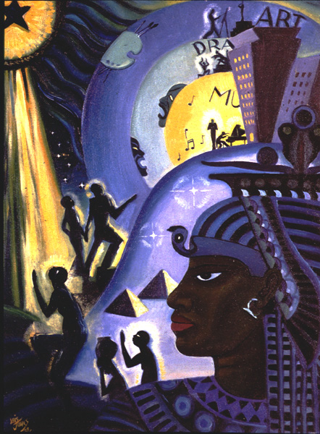
In 1925 Alain Locke published his important essay "Legacy of the Ancestral Arts" in the March issue of Survey Graphic magazine that he edited about Harlem, the neighborhood where most African Americans in New York lived. In this essay, reprinted later that same year in his significant book The New Negro, Locke implored African American artists to look to Africa for inspiration and aesthetic ideas just as European modernists such as Picasso, Braque, and Modigliani had done during the previous two decades. He also addressed the need to overcome the visual stereotypes of the nineteenth century, which had codified a distorted view of the physical features of people of African descent. Locke's challenge to African American artists was made during a period when artists and intellectuals were approaching their African cultural heritage from a perspective of self-discovery.
6. Lois Mailou Jones, The Ascent of Ethiopia, 1932, oil on canvas, 23 x 17” Milwaukee Art Museum

Many artists and poets of the astonishing flowering of literary, musical, and artistic talent known as the Harlem Renaissance created imaginary African settings or people in their work. In the United States, this translated into an idea of the Negro "soul," The poet Langston Hughes connected African Americans with the Congo, Nile, and Mississippi rivers in his famous poem "I've Known Rivers," and Countee Cullen asked, "What is Africa to me?" in his 1925 poem "Heritage." (…)

Lois Mailou Jones (1906-1998) revisited the sense of Egypt/Ethiopia as a metaphor for an exalted African past in the black imagination with her 1932 painting The Ascent of Ethiopia. In this work she visually links contemporary African American creativity with the culture of ancient Egypt, represented by pyramids and the large pharaonic profile that dominates the foreground, suggesting a continuum of African achievement. Drama, music, and visual art are highlighted within concentric circles that organize and energize the composition. References to the arts emerge from behind skyscrapers just above the pharaoh's head, and each discipline is performed symbolically by black silhouettes. Art and civilization are linked graphically, mirroring the philosophical ideas of Locke, Du Bois, and other intellectuals of the period who felt that artistic and cultural achievement would help facilitate black acceptance into Western societies. (…)

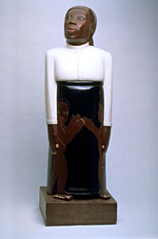
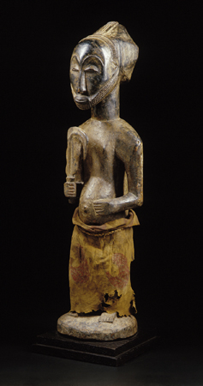
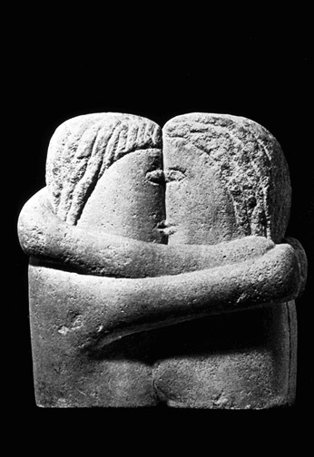

On the West Coast, Sargent Johnson (1887-1967) explored an interest in the physiognomy of African Americans in his sculpture. "It is the pure American Negro I am concerned with," he said in a statement published in 1935, "aiming to show the natural beauty and dignity in that characteristic lip and characteristic hair, bearing and manner; and I wish to show that beauty not so much to the White man as to the Negro himself." The 1933 sculpture Forever Free reveals Johnson's interest in color, form, and understated social statement. The sculpture depicts a dignified mother protecting her two children at her side. The frontality of the work, its closed form, and the stylization of and emphasis upon the head link it stylistically with some freestanding African sculpture, yet its simplified form gives it abstract qualities that also invoke modernism and the work of Johnson's European contemporaries such as Brancusi or Henry Moore. (…)
Sargent Johnson, Forever Free, 1933, polychrome wood

Museum of Modern Art
Hemba figure, Congo, Wood and cloth

Constantin Brancusi, The Kiss, 1912, plaster
Aunt Jemima cookie jar, United States.

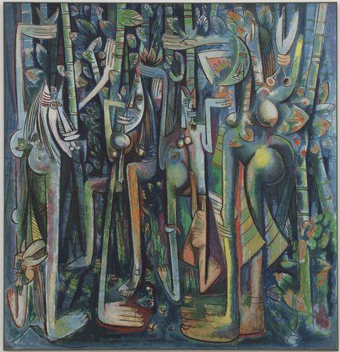
Cuban artist Wifredo Lam (1902-1982) brought a somewhat different perspective to his career. He grew up in Cuba the son of a Chinese father and a mother of Congo descent, and his godmother was a priestess of Lucumi, also known as Santeria, a religion that developed in Cuba from Yoruba belief. He moved to Europe at age twenty, living first in Spain, then in Paris, where he came under the artistic influence of Picasso and Cubism and also of André Breton and the Surrealists. In 1941, at the beginning of the Second World War, Lam returned to Cuba. There he combined the diverse cultural and artistic influences of his life in works such as The Jungle.
Wifredo Lam, The Jungle, gouache and paper on canvas, 1943, 7’10” x 7’6”, Museum of Modern Art, New York. One figure to the left of center has a mask face, which refers at once to African art and Picasso's early work, and another to the right has a face in the shape of a crescent moon. In Santeria, the moon is believed to be the wife of the sun, and a crescent-shaped new moon signals a period ripe for ritual activity.

Painted in 1943, The Jungle reveals Lam's use of the geometry and multiple simultaneous views of Cubism, the juxtaposition of images in sometimes surprising configurations found in Surrealism, and the iconography and meaning found in Afro-Cuban religious practices. Figures that combine human, animal, and vegetative elements suggest humankind's oneness with nature. (…)

New York artist Romare Bearden (1911-1988) explored a variety of techniques and themes during his career, but he is most known for his collages portraying African American life in the South and in Harlem. Bearden became prominent as an artist during the Civil Rights era in the United States and was part of a group called Spiral, inspired by the Civil Rights movement of Martin Luther King, Jr. and the 1963 March on Washington, Spiral organized an exhibition in 1964 called Black and White (…)

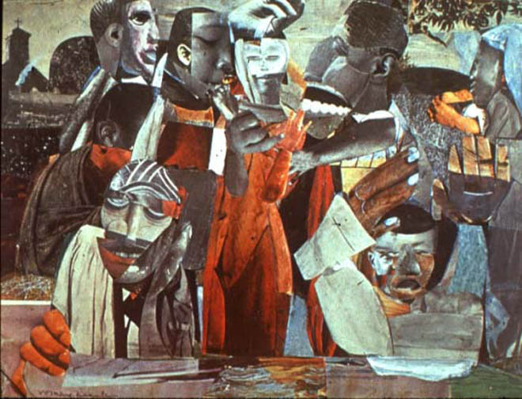
From Bearden's discussions with Spiral grew an interest in devising photomontage collages, including a series drawn from his experiences growing up in North Carolina. (…) A 1964 collage, The Prevalence of Ritual: Baptism, combines Bearden's interest in and study of modern art stylistic movements such as Cubism, Surrealism, and Abstract Expressionism with African and African American cultural references. The title of the work links baptism rituals in the black church with older African religious and social rituals, which is emphasized by the figure to the lower left with a mask-like face. The top of the face is drawn from African mask imagery, but the lower portion of the mouth and chin are collaged from photographs. This juxtaposition of the old with the new speaks of the effort made by many artists in the African diaspora to reconcile their heritage with their current circumstances.
Romare Bearden, The Prevalence of Ritual: Baptism, collage on paper, 1964

Hale Woodruff (1900-1980) commemorated the centennial of the 1839 Amistad mutiny - a celebrated incident when Mende captives took over a slave ship off the coast of Cuba to free themselves - with a series of murals at Talladega College in Alabama. In their form and inspirational character the works show the influence of the Mexican muralists Diego Rivera, Jose Orozco, and David Siqueiros, whom Woodruff had met during a Mexican sojourn. The subject of the murals served to connect African Americans with Africans in the historical struggle for freedom. (…)

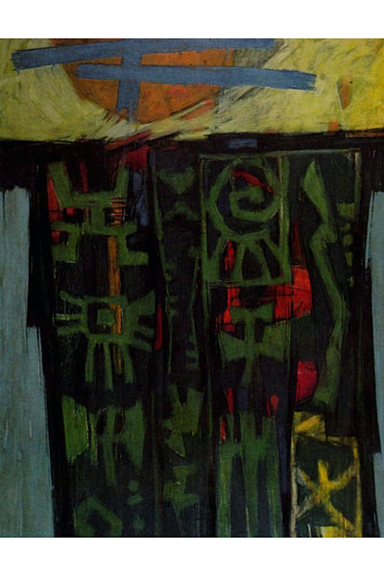
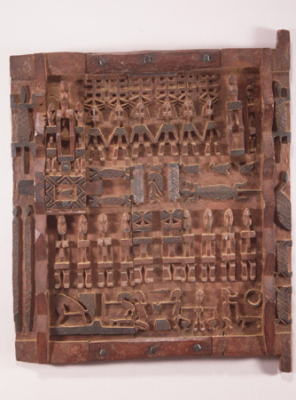
Woodruff completed several important mural projects after moving to New York, but by the mid-1950s he had abandoned social realism in favor of abstraction. His 1969 painting Celestial Gate shows how he eventually turned to African design for subject matter in his later abstract work. Painted in the expressive, painterly style of Abstract Expressionism, the work's underlying motif is a Dogon granary door decorated with images based upon Asante gold weights. Woodruff said, "I have tried to study African art in order to assimilate it into my being, not to copy but to seek the essence of it, its spirit and quality as art." He combined elements from two different African societies to make what can be interpreted as a pan-Africanist statement calling for unity among various peoples of African descent.
Hale Woodruff, Celestial Gate, 1953, oil on canvas, 50 x 40 in. Spelman College Museum of Fine Art
Dogon Granary Door, Mali

Getting Behind the Mask: Transatlantic Dialogues


(…) However, during the 1960s, black nationalism, the Black Arts movement, the revitalization of pan-Africanism, and the optimism spawned by the increasing number of African nations throwing off the yoke of colonialism contributed to more aggressive explorations of African art and culture by younger African American artists, writers, and intellectuals. Many travelled to Africa for varying lengths of time, and the pan-African ideas of Kwame Nkrumah, Ghana's first leader after colonial independence, were inspirational to many in the diaspora. (…) This kind of direct experience allowed many in the African diaspora to gain a fuller understanding of African cultures, to develop relationships with people and artists living in Africa, and to confront their similarities to and differences from Africans. The romantic projections of Africa under the generic terms of Ethiopia, Egypt, or Congo gave way to more specific images. Artists began to penetrate the facade of form in African art. They began to get behind the mask. (…)
7. African Slave Trade showing scope of dispersion

Locke’s “Legacy of the Ancestral Arts” is the next reading in this volume.

